Froghall Drive History
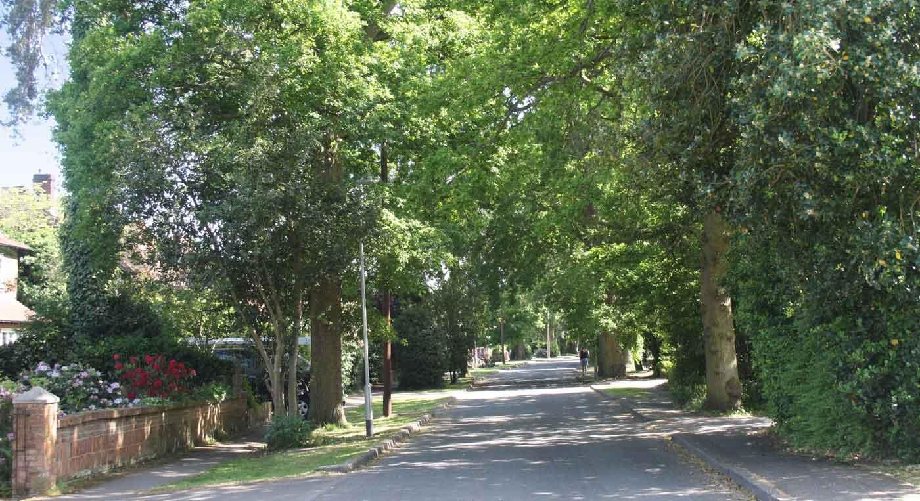
The following material appeared originally on the Froghall Drive Community website but, since the website has been discontinued, it has now been converted to an eBook at the request of the Residents’ Association.
The material was created and compiled by Christopher French and is made available with his family/estate’s approval, including material he specifically requested be preserved. Copyright remains with his estate.
The first section covers the history of the Drive and Frog Hall.

The second gives the history of pubs and breweries in Wokingham.

Frog Hall Drive - or Froghall Drive?
Introduction by Chris French
The council oddly uses both variants on the name boards at the entrance to the Drive.
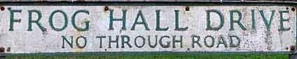
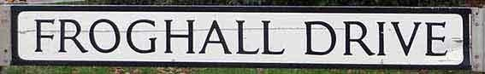
Which is the correct spelling??
The premise is that there was a house, in a marshy area near where the The Three Frogs pub is now, on the main road - called Frog Hall. The area around it was called Froghall Green (and still is - though successive maps show it further east or west and sometime north or south of the main road!). This house was eventually demolished. Meanwhile, there is a substantial house at the end of the drive, south of the main road. Its name at the time of its construction is not yet known. After being called Waterloo Lodge for many years, since the 1850s, then Frog Hall and then briefly Buzzacott House, this house was finally renamed Frog Hall. The name of the drive then became Frog Hall Drive. (Why the pub is called the Three Frogs has yet to be discovered).
Froghall Drive and Frog Hall
The history of Frog Hall Drive and its houses are of course dominated by the history of Frog Hall. I believe that our house (No. 19) was built in 1955, but the fact that 10 different people owned Frog Hall in the last 100 years means there is MUCH more information available about its history. I am lucky that Les Roland at No. 40 (see below) has already done a great deal of research and obtained many original documents, including an interesting set of photos of the drive, from 1954. He kindly lent all this to me for several weeks and from these, and my results from much time Googling, I have produced a history of Frog Hall and the Drive including photos, maps and documents relating to changes of ownership in the period studied.
Maps
I had a couple of old paper Ordnance Survey maps which include Frog Hall Drive and I then started searching out others online. So far I have a collection going back a couple of hundred years - I have identified the key changes as we go further and further back. When I circulated this to other residents of the drive I had at least a dozen expressions of interest and two great sources of more detailed information (see below).

Les Roland (No. 40)
Les had already done quite a lot of research into the drive, but more specifically the history of No. 40, for personal reasons. The Cottage, as it was once called, has often been sold as a separate property from the hall. I have the originals of his research and have taken the generic facts from it and will be expanding them as I get more information. An interesting set of photos of the drive exist, from 1954.
[NB: Les Roland died in February 2016].

Stuart Ingwell (No 47A)
Stuart had the deeds for No. 47A and supporting maps showing the period when the hall was called Buzzacott Hall, in the late 1940s. This information relates to the area around Nos. 43/45/47 and 47A.
Sylvia Smith
Following correspondence on the "Memories of Wokingham" Facebook group pages, Sylvia Smith sent me some detailed information regarding Nos 44 & 46:
I believe my father Richard Emlyn Hughes bought 10 Buckhurst Grove off Peter Telling in the summer/autumn 1963, I believe Telling was living in the house at the time. The property consisted of the bungalow set on 1 acre of land and an acre and a half of lake, also the alleyway leading from Buckhurst Grove to Froghall Drive.
When Telling sold Froghall to Charlesworth he kept the old granary (No 44) and adjoining land (where No 46 is now). The granary was a timber building up on stone mushroom. In 1963 it was occupied by Len and Maud(?) Telling, a cousin (I believe) of Peter Telling. The dwelling consisted of a small lounge, a dining room, a kitchen and one bedroom. In approximately 1965/66 my father Richard Hughes bought the adjoining land (where No 46 now stands) and maybe bought No 44 at the same time: I'm not really sure when he purchased 44 as Len and Maud Telling carried on renting it off of my father. When they did move out it was rented out until my brother Geoffrey Hughes moved in after he was married in 1970. This was transferred to Geoffrey Hughes and sometime in the next year or so the house was knocked down and the present house was built.
My father obtained permission to build a bungalow on the land (No 46). Charlesworth argued that we didn't have a right of way to get to the land and stood in front of diggers trying to get there to do the ground work, it ended up going to the courts in London which found in our favour. My father owner built the bungalow sub contracting the labour. I bought the home in 1968 when I married. The alleyway has never been owned by No 46 as I stated early it was part of 10 Buckhurst Grove, but there was the right of way over the land in front of No 46 for residents of Buckhurst Grove who used the alleyway.
About 1976 Richard Hughes sub-divided 10 Buckhurst Grove into 2 titles and built the house down by the lake, 70 Waterloo Road.
I knew the Tapsells very well, they were wonderful neighbours. I still have photos of George with my boys but unfortunately I don't have any of No 42 or No 44 before they were demolished. Sylvia Smith (May 2018)

The History of Frog Hall Drive

Chris French, May 2020

Introduction
The history of Frog Hall Drive (FHD) and its houses are of course dominated by the history of Frog Hall. The date of construction of Frog Hall is not known although it has been referred to as Queen Anne in a sale document. Queen Anne was on the throne of England from 1702 until 1714. There have been a number of alterations and additions to the main building. The main entrance was originally on the west side but later on further building added a new front and the entrance was moved to its present position. It is possible to see the different type of architecture where the new front was added on. It is thought the later parts are Georgian. When in the 1970s the hall was converted into twelve flats the servants wing on the east side was extended.
The houses numbered 38/40/42 have had a more unusual history than most of the rest of those in the drive, and Les Roland (No 40) has researched the history of his house in much depth. His findings have contributed greatly to this document, for which I am greatly indebted.
In the 50s there was much legal wrangling when "The Cottage" (No. 40) was kept a separate entity to the hall and the rest of its grounds and not sold as part of the estate. There were many boundary disputes.

Froghall Drive or Frog Hall Drive?
The premise is that there was a house, in a marshy area near where the Three Frogs pub is now - called Frog Hall. The area around it was called Froghall Green (and still is - though successive maps show it further east or west and sometime north or south of the main road!). Whether the house was named after the Green or vice versa is not clear. This house was eventually demolished and the pub created in the same place.
After initially being called Waterloo Lodge for many years, since the 1850's, then Frog Hall and then briefly Buzzacott House, the hall was finally renamed Frog Hall in the 1950's. The name of the drive then became Frog Hall Drive. (Why the pub is called the Three Frogs has yet to be discovered).
In the early days the hall was surrounded by its estate of grounds and fields, bounded to the north by the London Road, to the west and east by Rances Lane and Clay Lane and it went south beyond Waterloo Road. In time the estate itself shrank, leaving just the gardens surrounding the hall and a few adjacent buildings. Eventually these buildings were also sold off, leaving just the hall as we know it today.

Key dates and events
17th Century
13 August 1628
An early mention of our pub, if not our road, appears in this charitable entry: "William Thare, will, 13 August 1628, whereby a rent-charge of £3 3s issuing from three cottages in Denmark Street, and land containing 1 a. 1 r. 11 p. near the 'Three Frogs' in London Road, was granted for distribution amongst six decayed tradesmen, 10s. apiece, and 3s for the expenses of the trustees."
18th Century
1761
The Rocques Survey of Berkshire map shows a building called Froghall and just north west of it is an area called Froghall Green. Co(p)pid Beech Lane is shown (now the London Road). "Froghall" appears on the map roughly where the pub is but the un-named building a little further south is possibly what we NOW call Frog Hall.
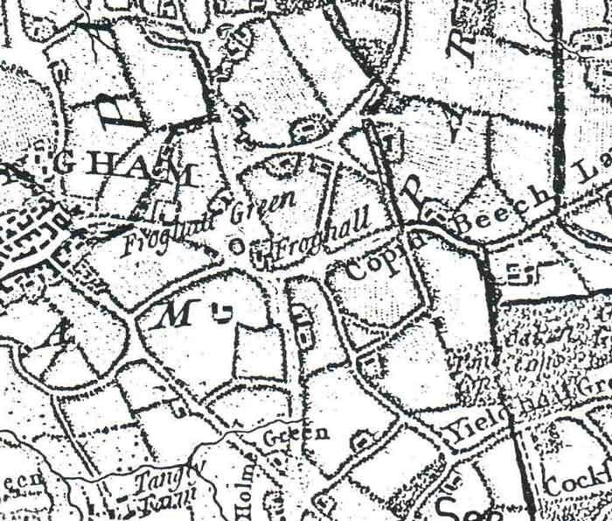

19th Century
1815
This is the date of the Battle of Waterloo – and presumably the reason for the name of the Hall for many years.
1817
An "enclosure map" of this year shows the Hall and surrounding area, owned by R. Crabtree.
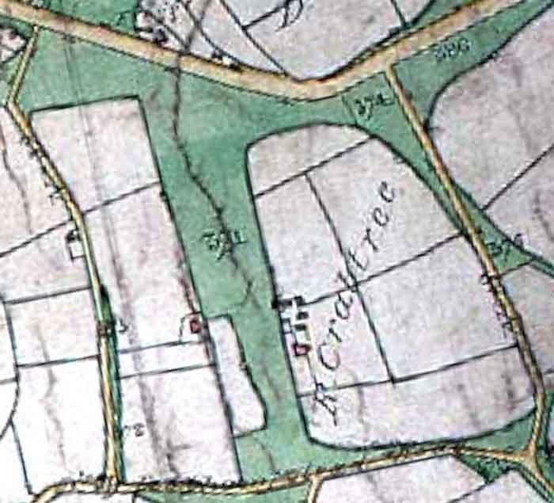
1818 & 1820
We know at these dates that Richard Crabtree was living in Waterloo Lodge. (This is the first use of the name "Waterloo Lodge" that I have found).
14 March 1840
The birth at Waterloo Lodge, Wokingham of a daughter to the wife of John Hulme was announced in the Reading Mercury.
11 July 1840
In an Indenture, Maria Crabtree late of Waterloo Lodge, executor of Richard Crabtree, leased Waterloo Lodge to John Walter II (of Bearwood) for two years.

26 September 1842
An indenture referred to Waterloo Lodge. It appears John Walter II, who was M.P. for Nottingham and who lived at Bearwood, now owned Waterloo Lodge. He died in 1847 and it passed to his wife Mary. In an Indenture of Settlement she appointed a certain James Charles Lettcourt to be a trustee jointly with Alexander Dobie and Thomas Cooke.
12 September 1846
Arthur Fraser Walter (the second son of John Walter III) was born in Waterloo House (as it was sometimes called). In 1894 he inherited the Bearwood Estate on the sudden death of his elder brother (born in March 1846).
1855
We know at this time that Mrs Hulme (a housekeeper ?) was living in Waterloo Lodge.
25 March 1859
In a Reconveyance, between Rev William Pochin Larken and John Walter III of Bearwood, Waterloo Lodge or Waterloo Hall had an area of 193 acres. There was also a reference to other parcels of land. Under this document John Walter paid the Rev. William Larken £6400 as a consideration.
23 October 1867
On a sketch map of this date a different layout was shown for the Hall.
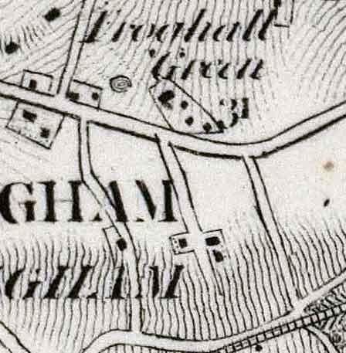
1875
In a Succession Duty on Property in Expentancy, John Walter III inherited Frog Hall from Mary Walter derived from John Walter II in a will dated 9/2/1847. It was occupied by Colonel Guines at a rent of £150 per year but was then sold to Mr William Goodchild for £6000. This was recorded as

the mansion house plus 53.3.11 acres of land. Other parcels of land, 16.1.30 acres - James Gale Barford for £1090, 3.1.5 acres - Mr Marshall Pattens Ash for £500, and 72.2.22 acres Sydney Alex Hankey £6400, were sold off at the same time. Thus presumably the original farm was split up.
30 June 1883
An Ordnance Survey map of 6 inches to the mile, based on a survey from 1871-2, shows the building called Waterloo Lodge. The area called Froghall Green (approx. where St Crispins is now) is shown, as is the Three Frogs Public House. The railway is called London and South Western Railway (Staines, Wokingham and Reading Branch).
1887
We know at this time that Samuel Goodchild was living in Waterloo Lodge.
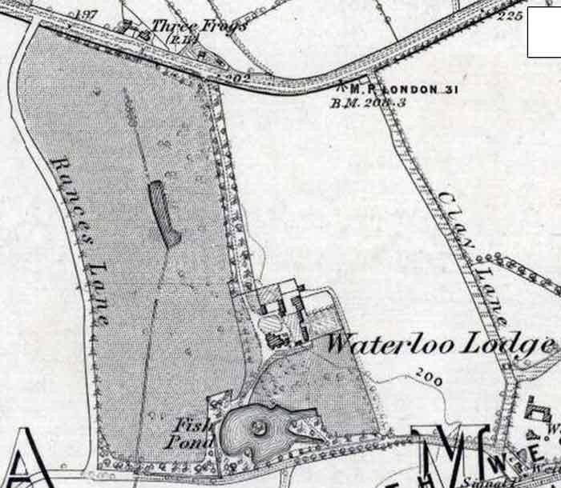
20th Century
31 May 1906
Samuel Holt Lomax made his will and appointed Charles Henry Lomax, John Chadwick Lomax and William Hamilton Alston as executors. Frog Hall, formerly known as Waterloo Lodge was a farm with an area of 54.099 acres. (This is the first use of "Frog Hall" I have found for the building). It stretched from London Road in the north to the railway in the south; Clay Lane was the eastern

boundary and Rances Lane the western one. Waterloo Road crossed the farm and there was a drive from the house to it as well as to the main road.
1911
We know at this time that the Barnard family was living at Frog Hall.
1912
An Ordnance Survey map of 23 inches to the mile scale, using an original survey of 1870, revised in 1909, names the building Frog Hall. It showed Waterloo Road and the Waterloo Crossing on the railway line.
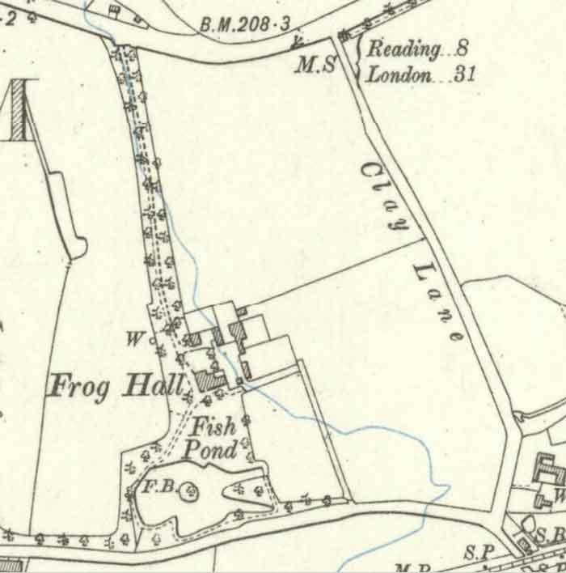
06 November 1918
Charles Henry Lomax and William Hamilton Alston sold Frog Hall to James Thomas Sydenham.
13 May 1921
J T Sydenham made his will, with his wife Ada amongst his executors.

08 August 1921
J T Sydenham was last seen alive on this date and was found dead on 22/August/1921 at Easthamstead Wood, Easthampstead.
06 March 1922
Frog Hall was purchased by Vaughan Adrian Stokes, a Captain in the Army, who was a local farmer. It is rumoured that he drowned himself in the pond!
26 July 1927
James Rolt purchased Frog Hall from V A Stokes.
01 October 1930
Charles Etwell had a yearly tenancy from James Rolt. Etwell was a farmer who ran cattle and grew hay in the fields east and west of the drive. He also ran the local milk delivery business.
James Rolt was a Kings Councilor and made Frog Hall his retirement home.
He and his wife Grace had a large establishment with as many as eight servants in the house and a large force of groundsmen. The head gardener lived in the lodge at the top of the drive (now No 2) whilst his second gardener lived in a cottage on the opposite side of London Road. He had previously been the coachman for the Rolts but when they moved to Wokingham they employed a chauffeur who lived with his wife and two sons in the Cottage (now No. 40). For many years two landaus were kept in the garages although never used.
During this time the grounds were well kept. The drive up to London Road was gravel flanked by grassy banks and a profusion of rhododendrons.
The chauffeur's name was Lane and much of this section of information has been supplied by his younger son Frank.
30 December 1937
Town Planning Agreement between Richard Lowndes, Charles Medway, Frederick Charles Ihlee and Berkshire County Council.
1938 - 39
First Grace and then James Rolt died and are buried in All Saints churchyard - on the left inside the gate entrance from London Road.
1937
We know at this time that Richard Crabtree was living at Waterloo Lodge.
14 September 1939
Harmar Ltd bought the property and 53 acres for £5500.
7 March 1940
Permission was granted to W Timothy Donovan to use Frog Hall as a nursing home.
22 April 1940
Harmer Ltd sold Frog Hall and about 10 acres of land to James Cooper Budge and Alice Budge with a right of way from London Road, for £2500. They got a mortgage of £1,650. At that time the grounds

included the frontage onto Waterloo Road. They ran a nursing home in Frog Hall, with Donovan as the manager. The sale covenant insisted that they kept the hedges and fences in good order and were not allowed to keep poultry or pigeons.
29 September 1940
The yearly tenancy with Etwell terminated after one year's notice.
7 September 1945
Frog Hall was put up for auction with Watts & Sons by the Budges but did not reach the reserve price.
6 March 1946
The Hall was sold privately by the Budges to James Buzzacott for £8000 (for and as a donation to the Salvation Army Homes) to be known as the Nurse Emily Buzzacott Home in the memory of Miss E Buzzacott. He renamed it Buzzacott Hall and the Salvation Army ran it as an old people's home until they moved out themselves, as they found it too expensive. Somewhere about this time there was an idea to convert Frog Hall into an hotel, but this was turned down because the drive was considered too narrow, if cars were parked in it, for a fire engine to come down it in the event of an emergency.
27 January 1950
The London Gazette announced the death of Edith Marian Butterworth, of Buzzacott Hall.
25 June 1952
The London Gazette announced the death of Alice Sarah Dunn, of Buzzacott Hall. This lady, and the one before, were presumably residents of the old people's home.

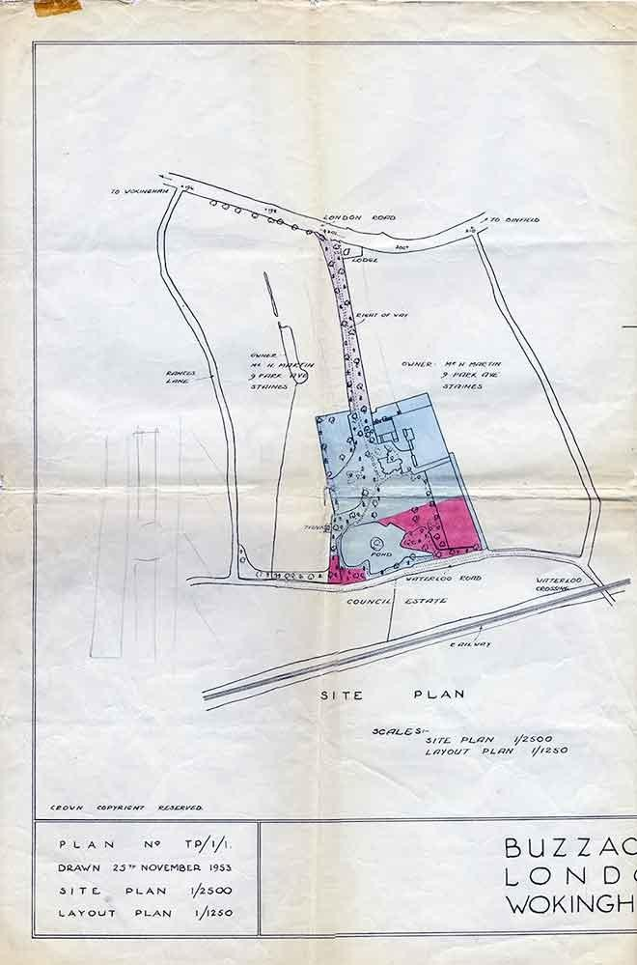
Buzzacott Hall Plans 1953
Site Plan

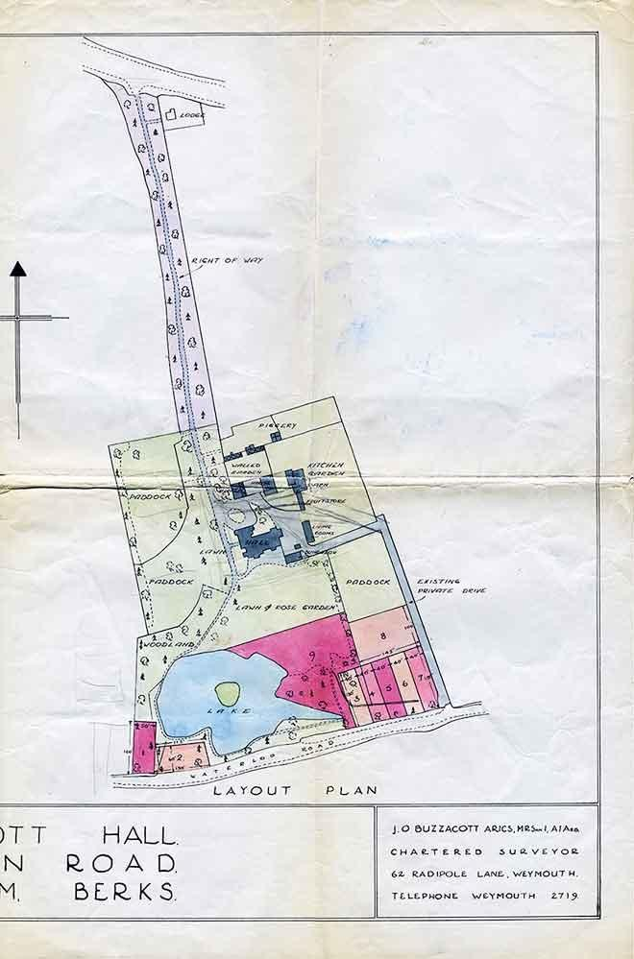
Layout Plan

14 September 1954
Buzzacott Hall and the remaining land, except for "The Cottage", was auctioned by Foster & Cranfield, Martin & Pole. It was freehold with vacant possession.
22 November 1954
J Buzzacott completed the sale of Frog Hall and the land, including the Barn and buildings (now 42 Froghall Drive) etc, to Peter Sidney Telling. Along with Frog Hall (then called Buzzacott Hall) Telling bought an additional seven acres of surrounding land. Buzzacott retained "The Cottage", now 40 Froghall Drive, for himself and carried on living there with his housekeeper Betty Miller.
24 February 1956
Telling sold some land to Ian and Margaret baker, where "Nether Staples" now is.
23 July 1956
Telling sold the Hall to Harry and Florence Lucy Charlesworth.
1 November 1956
There is a lengthy report on the many aspects of a dispute between Buzzacott and Telling over their exact boundaries, rights of way, fences, drains etc.
1 May 1962
We know at this time that the Charlesworths were living in Frog Hall.
February 1967
Plans were drawn up for a new house, to be built immediately in front of the hall. This proposal was presumably scrapped or permission was refused.
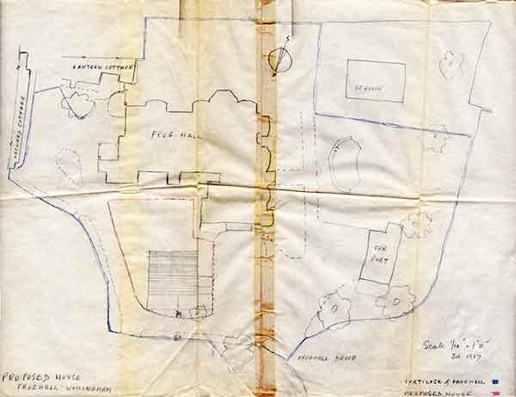

1968
We know at this time that the Charlesworths were living in Frog Hall.
27 December 1970
James Buzzacott died. His address in the Gazette was given as "Buzzacott House, 40 Froghall Drive, Wokingham" and his occupation as a Retired Estate Agent.
19 April 1971
The Charlesworths sold the Hall to Den Hill Securities Ltd for £16,500 and presumably the rest of the land was split off.
31 July 1971
The National Westminster Bank (as executors of J Buzzacott) passed 40 Froghall Drive to Betty Miller (previously J Buzzacott's housekeeper).
19 May 1972
The Hall was sold to Bachittar Singh Hothi, a director in several property companies, for £49,500 and he extended the servants quarters end and subdivided the whole into twelve leasehold flats.
Other relevant facts
Buckhurst Grove
After 1954, when Telling bought the Hall and grounds he built the houses in Buckhurst Grove but was unable to sell them until he provided a private footpath from the blind end of Buckhurst through to Froghall Drive so that the residents had easy access up Froghall Drive to the bus stop in London Road near the Three Frogs. Telling had also by then sold Frog Hall to the Charlesworths who insisted that there was a gate at each end of the footpath and the residents of Buckhurst be provided with a key. This footpath and gates form part of the property of No 46 Froghall Drive.
Over the years this footpath and in particular the locked gates fell into disrepair but were reinstituted by the owner. However when he died his widow had the locks removed as she found it difficult to open them so that she could get through to Waterloo Road and the Rances Lane shops. Unfortunately this meant that all and sundry could make their way through from Waterloo Road and security became a problem in and around Frog Hall and the blind end of Froghall Drive. (2004) All being well the owner of 42 (Alan Scott) hopes to re-establish the lock on at least one of these gates when the new owner of the property to the west of the footpath improves the fencing and gates on his land.
Land registry maps of 1964 & 65 show this footpath but 46 Froghall Drive is not marked, as it was not built until later.
Land registry maps dated 1973 show both the footpath and 46 Froghall Drive. It ends on the land leading from the right of way alongside Frog Hall leading to 46 Froghall Drive. Thus people coming from Buckhurst would walk over land that presumably belonged to 46 Froghall Drive.

38/40 Froghall Drive
North of 40 Froghall Drive was a walled garden, which also contained a glass house. Mr. J D Andrews purchased this area plus other land from Telling and he then built what is now 74 Waterloo Road. Later on Andrews built a house within the walled garden and subdivided this plus the barn from the original parcel. The Andrews then moved into this house (Nether Staples 38 Froghall Drive). A further house was also built, again accessed from the private road off Waterloo Road.
For £150 a strip of land 12ft by 41 ft was sold by the owner of 40 Froghall Drive to the owner of No. 38, Mr Andrews, to give him a vehicular access from his house to Froghall Drive. However a covenant was applied so that no further building on 38's land except for a one-storey garage without the written consent of the owner of 40 Froghall Drive. At this time the barn was part of 38 Froghall Drive and used as a general-purpose store and garage. The vehicular access was up the private road from Waterloo Road.
42 Froghall Drive
When Tilling built Buckhurst Grove he brought his foreman carpenter George Tapsel with him as general foreman. He moved into and eventually purchased a building, which was line of rooms to the east of the Hall. These rooms were originally sleeping quarters for the servants of visitors to the Hall. At one time a generator and storage accumulators were installed in the end room to provide electricity to the hall and the cottage. Eventually these were removed when the buildings were connected to the mains supply. Tapsel also purchased the old fruit storage building with the chimney stack at one end, which he used as a general (junk) store.
Tapsel carried many alterations and additions to the rooms and lived there with his wife and three sons for many years. This became 42 Froghall Drive. When he died in 1987 he left the house to his wife and the store to two of his grandsons (sons of the two of his sons who were still in the UK - the third son had already emigrated to Perth WA). Eventually his wife who had difficulty moved into sheltered accommodation and the house stood empty for a long time. In 1995 it was sold to a developer, knocked down and a four-bedroom house built in its place. At the same time the storage sheds were recombined with the property and used by the builder as a store etc. However the first purchaser of the new house did not want the store and eventually it was sold off and was split into two. The end nearest the barn was rebuilt and became a garage for it. The other part was purchased by the owner of the house on the private road behind thus giving him access to the right of way alongside Froghall Drive.
The Lake
Early maps, from 1883 at least, show that the grounds of the Hall included a Fish Pond, with an island. A lawn led down to the lake from the Hall. This is now in the grounds of No 70, Waterloo Road.
Frog Hall
Below is a list of the owners of Frog Hall, followed by a collection of historic maps.

Owners of Frog Hall
This is a simple list of the owners of Frog Hall (or whatever it was called at the time). Whereas my more detailed history has dates where known, this is simply a set of years. Even so, some are not known or are just an estimate.

Year | Owner | Name of Building
1847? | John Walter III | Waterloo Lodge
1875 | William Goodchild | "
prior to 1906 | Samuel Lomax | Frog Hall
1918 | James Sydenham | "
1922 | Vaughan Stokes | "
1927 | James Rolt | "
1937? | Richard Crabtree | "
1939 | Harmer Ltd. | "
1940 | James / Alice Budge | "
1946 | James Buzzacott | Buzzacot Hall
1954 | Peter Telling | Frog Hall
1956 | Harry / Florence Charlesworth | "
1971 | Den Hill Securities | "
1972 | Bachittar Hothi | "

Froghall Drive - the Maps

Chris French, May 2020

Introduction
There follow some maps of Froghall Drive, starting with the present day (almost) and working backwards about 200 years, in 7 steps.
In all cases (bar one) I've tried to crop the maps to the same shape and with the same coverage, to make comparisons easier.
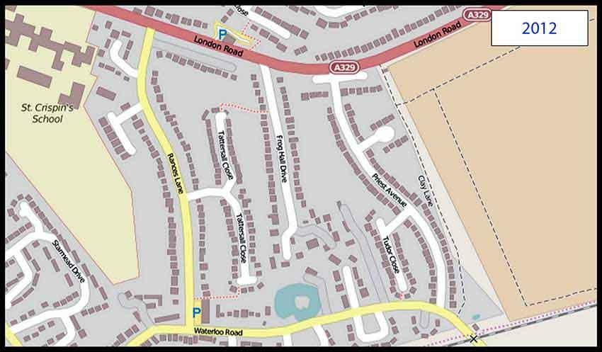
© OpenStreetMap contributors
2012: Here we have what we know today - give or take the new houses being built east of Clay Lane. I'm using OpenStreetMap in this case, because it's the most up to date and it has the street names. OpenStreetMaps are created and maintained by volunteers. A disadvantage is that is doesn't show the garden/land owned by each house.

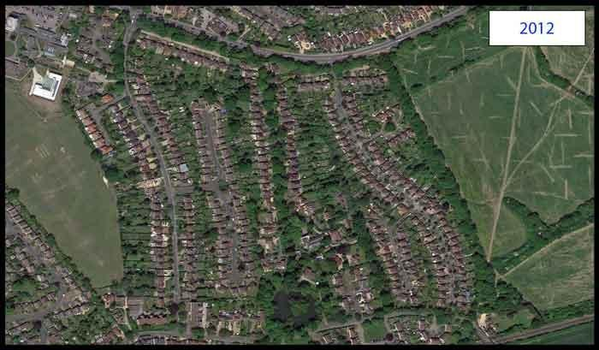
2012 again: If you prefer, here's a shot taken from my helicopter (or was it Google Maps?). As we know, in the real Google Maps you can zoom in and see what's on someone's washing line ......
Another item that is more obvious than in the maps is the strip of trees runnng north-east from the near southern end of Clay Lane.
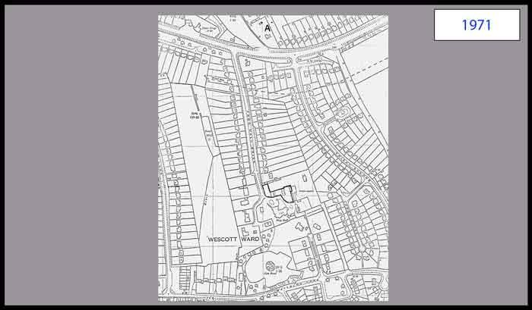
1971: This map does not cover the same area as the rest, but most importantly fills in the gap between the 2012 and 1958. The key thing is that it shows in detail all the houses built on both sides of the drive (except for the newest ones such as 47A).

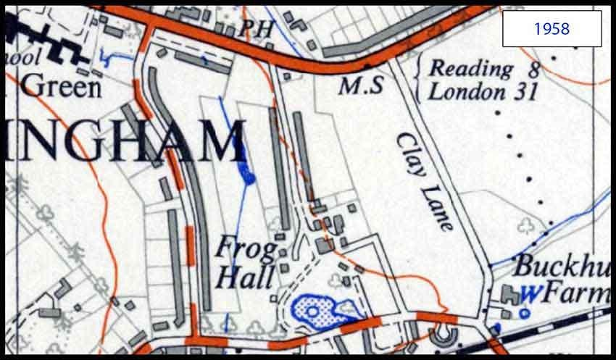
1958: Going back 50 years shows a significant set of differences:
- No Priest Avenue.
- No Tattersall Close - just the pond and streams that it is built over.
- Most of FHD has been built along, but not all.
- There are houses on the north side of London Road, but not the Bean Oak estate. Also a few opposite the pub.
- There are no shops on Rances Lane.
- Buckhurst Farm is prominent.
- The area round St Crispins was called "Frogall Green" on this map. On all earlier maps it is correctly spelt "Froghall Green", so I assume this is a typo.
- The only road named is Clay Lane.
- What is now Buckhurst Grove appears to give a secondary access to the hall, from Waterloo Road.

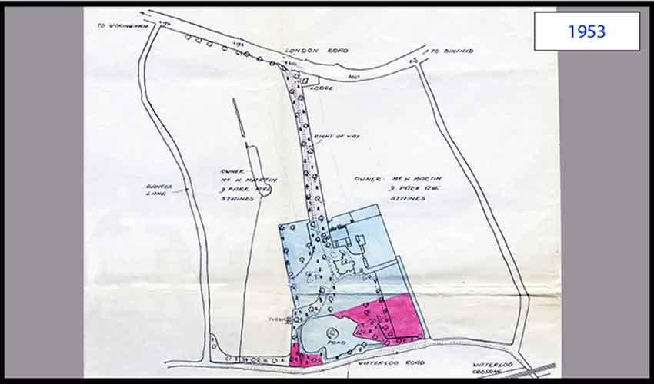
1953: Again, this map (trimmed from a larger plan) does not cover the same area as the rest, but shows that 5 years earlier the houses had not been built down the main part of the drive. It shows who owned the land either side of the drive, a Mr. Martin from Staines. The full map shows that the land south of Waterloo Road is a "Council Estate".
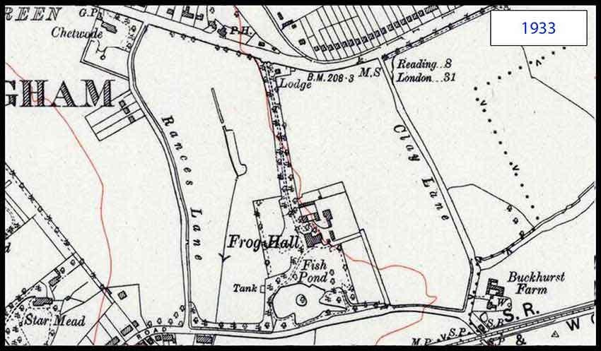
1933: Just 20 years earlier and back to an Ordnance Survey map:
- At this stage there are no houses on FHD, except the lodge and the hall's buildings.
- There are only 3 houses on Rances Lane - and Chetwode.
- Star Mead is another obvious large house.

- We have the Southern Railway - Staines & Wokingham Branch.
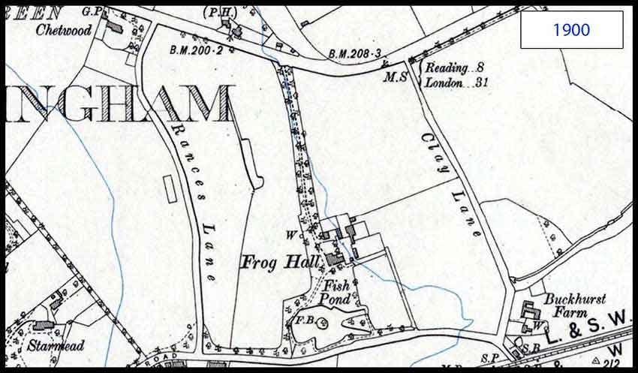
1900: Another 30 years back and:
- No houses on Rances Lane.
- No lodge on FHD.
- Frog Hall has not yet incorporated the area to the west of the house into its gardens, but otherwise appears near enough the same.
- We have the London and South Western Railway - Staines Wokingham and Reading Branch.
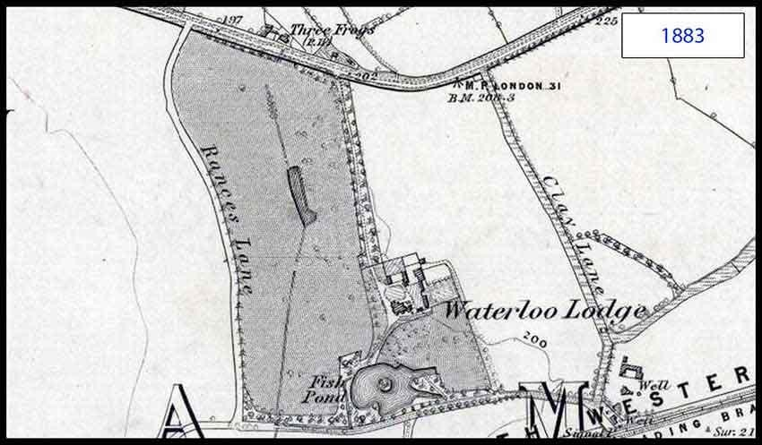
1883: The last jump back which gives a decent level of detail, I'm afraid. Now we see:

- Frog Hall has its original name - Waterloo Lodge (linked by name to Waterloo Road).
- The only 3 marked buildings are Waterloo Lodge, Buckhurst Farm (not named) and the Three Frogs.
To add to this, I'll next show FHD, in 1883, in the context of the whole of the east side of Wokingham ............
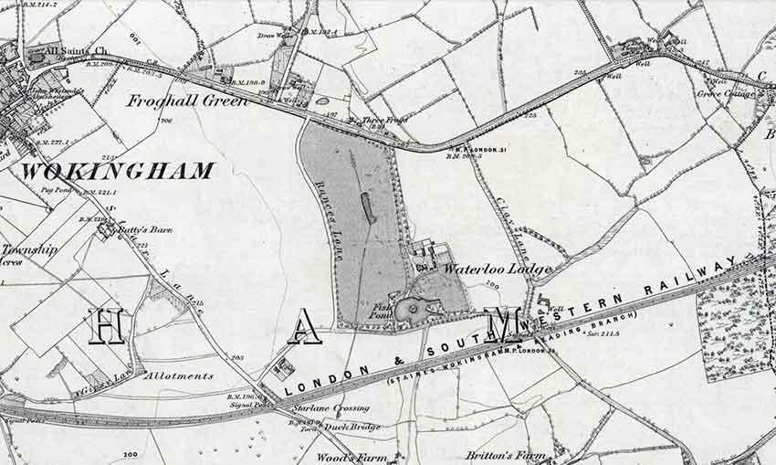
Now we can see how isolated the hall/lodge was and the Three Frogs was out in the sticks - I wonder where their custom came from?
The railway from Reigate to Reading was opened in 1849, while "our" railway, from Staines, was opened in 1856 and a joint station in Reading with the Great Western completed two years later.
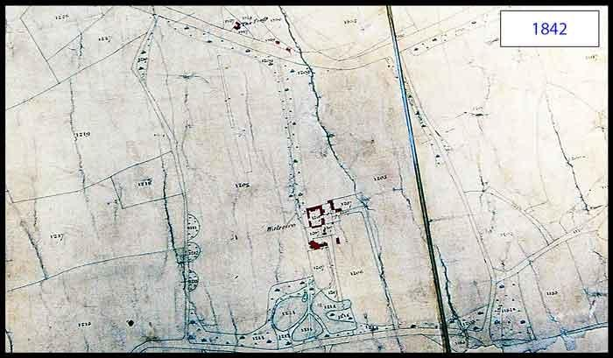

1842: This is a Berkshire Enclosures map, rather than an OS map. Enclosures were fields or plots of land and these maps concentrate on who owns which bits of land, but we don't have the names to associate with the plot numbering.
- Rances Lane and Clay Lane are there (though not named).
- There are several buildings, shown in some detail, making up Waterloo (Lodge) and its associated cottages and barns.
- The hall's lake is in three parts.
- The site of the Three Frogs is marked with the word "The Frogs". Whether it is a pub or a
private house, we can't tell. There are also a couple of other buildings to the east of it - all conveniently coloured in red.
1817: This is another Berkshire Enclosures map, rather than an OS map. Although somewhat lacking in detail, compared with earlier maps, it gives us a few interesting facts:
- Rances Lane is there (whatever it was called then).
- Clay Lane was also a significant lane, although the farm isn't shown.
- There are some buildings in the vicinity of Frog Hall, in the plot of land owned by "R Crabtree".

- The drive to the hall is not as clearly marked as before and the lake does not exist.
- The site of the Three Frogs is marked with the word "Froggs".

© Chris French 2020

Internet search results

Google Books
It is possible to search a vast number of online Google Books and the following items have come to light. They indicate who was living in the hall at certain times.
[Ref: 1] Tales & Poems – Mrs Stanley – 1818 Richard Crabtree of Waterloo Lodge was a subscriber (in those days subscribers paid a small sum that helped towards the publication cost of books they would like to encourage and their names featured prominently at the beginning of the book).
[Ref: 2] Universal Masonic Library - Volume 10 – Robert Macoy – 1855 – Mrs Hulme of Waterloo Lodge was a subscriber.
[Ref: 3] Records of the parish church and parish of Wokingham, Berks – Bertram Long – 1937 – "Richard Crabtree lived at Waterloo Lodge, now called Froghall. He died in 1836".

Wokingham remembers
This website was created to collect information about those from the area involved in, or affected by, the Great War.
[Ref: 4] A page about Dudley Barnard, who attended Wellington College and died on 10 February 1915, records that in 1911 his parents were living at Frog Hall. The 1911 Census Return for Frog Hall also shows it was occupied at that time by a Lionel Barnard, a solicitor, his wife, 3 guests and 4 servants.
[Ref: 5] A page about Samuel Lomax, who died on 10th April 1915, says his probate register entry has his address as Froghall, though he did not die there.
Miscellaneous finds
[Ref: 6] William Goodchild was a churchwarden, magistrate and finally Mayor of Wokingham in 1887. He lived at Waterloo Lodge.
[Ref: 7] As at 1st May 1962, the Berkshire Archaeological Society has a list of members, which included Major H and Mrs Charlesworth, of Frog Hall, Wokingham.
[Ref: 9] A Finnish web site, recording the ownership and pedigrees of racehorses, shows that in 1968 Major Charlesworth, of Frog Hall, owned a stallion called Cedar Lucifer, stabled near Ringwood.

The London Gazette
Searches of the Gazette show the name, date of death and last address of a number of people. Searching for Buzzacott finds two ladies and James Buzzaccott himself.

The London Standard
On June 25, 1913, an announcement was made regarding the auction of the Hall, as a freehold property. However, we don't know the outcome of the auction. It mentions that property is let on lease until 1918, which is when Lomax and Alston sold it to J T Sydenham.
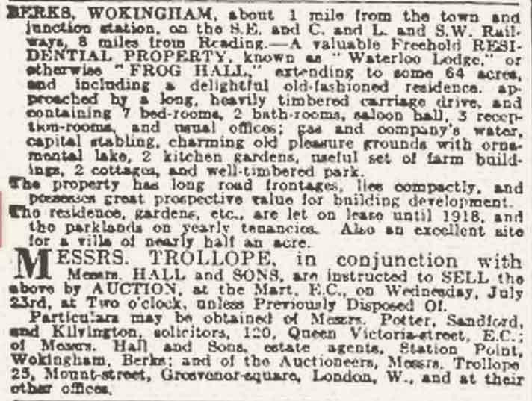
Leicestershire Record Office
An entry notes:
Richard Crabtree, Waterloo Lodge, Wokingham, Bucks
Encloses all the printed agreements, and advises Sir Henry not to abate any rents without careful investigation.
[Ref: 8] Enclosed: Bill to Sir Henry Halford from Richard Crabtree, 1820. £84 for valuing and letting farms at Wistow etc.
Priest Avenue
Priest Avenue is named after Albert Priest, Mayor of Wokingham in the 1930s.
The Three Frogs
The Three Frogs was first licensed as a pub in 1770, although the cottages that are now the heart of the building are much older.

Froghall Drive - the Maps

Chris French, May 2020

Introduction
There follow some maps of Froghall Drive, starting with the present day (almost) and working backwards about 200 years, in 7 steps.
In all cases (bar one) I've tried to crop the maps to the same shape and with the same coverage, to make comparisons easier.
© OpenStreetMap contributors
2012: Here we have what we know today - give or take the new houses being built east of Clay Lane. I'm using OpenStreetMap in this case, because it's the most up to date and it has the street names. OpenStreetMaps are created and maintained by volunteers. A disadvantage is that it doesn't show the garden/land owned by each house.

2012 again: If you prefer, here's a shot taken from my helicopter (or was it Google Maps?). As we know, in the real Google Maps you can zoom in and see what's on someone's washing line ......
Another item that is more obvious than in the maps is the strip of trees runnng north-east from the near southern end of Clay Lane.
1971: This map does not cover the same area as the rest, but most importantly fills in the gap between the 2012 and 1958. The key thing is that it shows in detail all the houses built on both sides of the drive (except for the newest ones such as 47A).

1958: Going back 50 years shows a significant set of differences:
- No Priest Avenue.
- No Tattersall Close - just the pond and streams that it is built over.
- Most of FHD has been built along, but not all.
- There are houses on the north side of London Road, but not the Bean Oak estate. Also a few opposite the pub.
- There are no shops on Rances Lane.
- Buckhurst Farm is prominent.
- The area round St Crispins was called "Frogall Green" on this map. On all earlier maps it is correctly spelt "Froghall Green", so I assume this is a typo.
- The only road named is Clay Lane.
- What is now Buckhurst Grove appears to give a secondary access to the hall, from Waterloo Road.

1953: Again, this map (trimmed from a larger plan) does not cover the same area as the rest, but shows that 5 years earlier the houses had not been built down the main part of the drive. It shows who owned the land either side of the drive, a Mr. Martin from Staines. The full map shows that the land south of Waterloo Road is a "Council Estate".
1933: Just 20 years earlier and back to an Ordnance Survey map:
- At this stage there are no houses on FHD, except the lodge and the hall's buildings.
- There are only 3 houses on Rances Lane - and Chetwode.
- Star Mead is another obvious large house.
- We have the Southern Railway - Staines & Wokingham Branch.

1900: Another 30 years back and:
- No houses on Rances Lane.
- No lodge on FHD.
- Frog Hall has not yet incorporated the area to the west of the house into its gardens, but otherwise appears near enough the same.
- We have the London and South Western Railway - Staines Wokingham and Reading Branch.
1883: The last jump back which gives a decent level of detail, I'm afraid. Now we see:
- Frog Hall has its original name - Waterloo Lodge (linked by name to Waterloo Road).

- The only 3 marked buildings are Waterloo Lodge, Buckhurst Farm (not named) and the Three Frogs.
To add to this, I'll next show FHD, in 1883, in the context of the whole of the east side of Wokingham ............
Now we can see how isolated the hall/lodge was and the Three Frogs was out in the sticks - I wonder where their custom came from?
The railway from Reigate to Reading was opened in 1849, while "our" railway, from Staines, was opened in 1856 and a joint station in Reading with the Great Western completed two years later.

1842: This is a Berkshire Enclosures map, rather than an OS map. Enclosures were fields or plots of land and these maps concentrate on who owns which bits of land, but we don't have the names to associate with the plot numbering.
- Rances Lane and Clay Lane are there (though not named).
- There are several buildings, shown in some detail, making up Waterloo (Lodge) and its associated cottages and barns.
- The hall's lake is in three parts.
- The site of the Three Frogs is marked with the word "The Frogs". Whether it is a pub or a
private house, we can't tell. There are also a couple of other buildings to the east of it - all conveniently coloured in red.
1817: This is another Berkshire Enclosures map, rather than an OS map. Although somewhat lacking in detail, compared with earlier maps, it gives us a few interesting facts:
- Rances Lane is there (whatever it was called then).
- Clay Lane was also a significant lane, although the farm isn't shown.
- There are some buildings in the vicinity of Frog Hall, in the plot of land owned by "R Crabtree".

- The drive to the hall is not as clearly marked as before and the lake does not exist.
- The site of the Three Frogs is marked with the word "Froggs".

© Chris French 2020

HISTORY OF 40 FROGHALL DRIVE

The date of construction of Froghall is not known although it has been referred to as Queen Anne in a sale document. Queen Anne was on the throne of England from 1702 until 1714.
There have been a number of alterations and additions to the main building. The main entrance was originally on the west side but later on further building added a new front and the entrance was moved to its present position. It is possible to see the different type of architecture where the new front was added on. It is thought the original building was Queen Anne and the later
Georgian. When in the 1970's the hall was converted into twelve flats the servants wing on the east side was extended.

"The Cottage" which is now 40 Froghall Drive did not have a separate Land Registry entry until May 18 1976 so that its history up until that date is very much associated with the main property of Froghall. The sale document for the auction in 1945 said it was built later than the main house and was in the Georgian style.

1761 Rocque’s Survey of Berkshire shows Froghall with its main entrance on the west side which was presumably before the Georgian extension was built. Just north east of Froghall the Green is marked and running from the ENE to the south side of Froghall
Coppid Beech Lane is shown. The general road pattern in the area is somewhat different from today. Neither the London Road (Bracknell to Wokingham) nor the Three Frogs appear.

The only available copy is a photostat of a small portion of Roques Survey so that it would be worthwhile following up this source of information.

11. 7. 1840 In an Indenture Maria Crabtree late of Waterloo Lodge, executor of Richard Crabtree leased Waterloo Lodge to John Walters for two years.

26.9.1842 An indenture referred to Waterloo Lodge.
It appears a John Walter who was M.P. for Nottingham and who lived at Bearwood
owned Waterloo Lodge. He died in 1847 and it passed to his wife Mary. In an Indenture of Settlement she appointed a certain James Charles Lettcourt in place of Francis Soames to be a trustee jointly with Alexander Dobie and Thomas Cooke.
(The Walter's Arms in Bearwood Road is named after John Walter)

17.3.1843 On a map Waterloo Road was shown joining the Easthamstead Road. The railway did not exist and the farm went further south. The Three Frogs is still not shown.

25.3.1859 In a Re conveyance between Rev William Pochin Larken and John Walter of Bearwood Waterloo Lodge or Waterloo Hall had an area of 193 acres. There was also a reference to other parcels of land. Under this document John Walter paid Rev William Larken £6400 as a consideration.

23.10.1867 On a sketch map of this date a different layout was shown for the Hall and Cottage 1875 Succession Duty on Property in Expentancy John Walter inherited from

Mary Walter derived from John Walter the elder in a will dated
9.2.1847 Froghall. It was occupied by Colonel Guines at a rent of £150 per year but was then sold to Mr William Goodchild for £6000. This was recorded as the mansion house plus 53.3.11 acres of land. Other parcels of land, 16.1.30 acres -James Gale Barford for
£1090, 3.1.5 acres - Mr Marshall Pattens Ash for £500, and 72.2.22 acres Sydney Alex Hankey £6400, were sold off at the same time. Thus presumably the original farm was split up

30.6.1883 An Ordnance Survey map 6 inches to the mile based on a survey 1871-2 shows the building called Waterloo Lodge. A Froghall Green
(approx. where St Crispins is now) is shown as is the Three Frogs Public House. The extension of 40 FHD is apparent. The railway is called London and South Western Railway (Staines, Wokingham and
Reading Branch)

1889 Ordnance Survey map 1/2500 does not show the glassed area in front of
the coach houses (garages). It shows the way down to Waterloo Road is north of the barn/stables. There is an additional structure in front of the study (see sketch)

The information to this date was obtained from the Berkshire Record Office Shire Hall mainly from a bundle of documents Deeds of John Walter Esq. Bearwood (D/E W1 T6 E981) and also from various Ordnance Survey maps held there.

31.05.1906 Samuel Holt LOMAX made his will and appointed Charles Henry Lomax, John Chadwick Lomax and William Hamilton Alston as executors. Froghall, formerly known as Waterloo Lodge was a farm with an area of 54.099 acres . It stretched from London Road in the north to the railway in the south, Clay lane was the eastern boundary and Rances Lane the western one. Waterloo Road crossed the farm and there was a drive from the house to it as well as the London Road.

1912 An Ordnance Survey map 1/2500 or 23.344 inches to the mile using an original survey of 1870 revised in 1909 called the building Frog Hall. It showed Waterloo Road and
Waterloo crossing on the railway. The glassed area in front of the coachhouses was shown plus a further extension beyond the study (see sketch)

10.4.1915 S H Lomax died. 11.12.1916 J C Lomax died
06.11.18 Charles Henry Lomax and William Hamilton Alston sold Froghall to James Thomas SYDENHAM

13.5.1921 J T Sydenham made his will with his wife Ada amongst his executors

08.08.1921 J H Sydenham was last seen alive on this date and was found dead on 22,8,21 at Easthamstead Wood Easthampstead.

06.03.1922 Froghall purchased by Vaughan Adrian STOKES Captain in H M Army who was a local farmer

26.7.1927 James ROLT purchased Froghall from V A Stokes

01.10.1930 Charles Etwell had a yearly tenancy from James Rolt. Etwell was a farmer who ran cattle and grew hay in the fields east and west of the drive. His also ran the local milk delivery business.
James Rolt was a Kings Councillor and made Froghall his retirement home.
He and his wife Grace had a large establishment with as many as eight servants in the house and a large force of groundsmen. The head gardener lived in the lodge at the top
of the drive (now No 2) whilst his second gardener lived in a cottage on the opposite side of London Road. He had previously been the coachman for the Rolts but when they moved to Wokingham they employed a chauffeur who lived with his wife and two sons in the Cottage. For many years two landaus were kept in the garages although never
used.
(The chauffeurs name was Lane and much of this section of information has been supplied by his younger son Frank)
During this time the grounds were well kept. The drive up to London Road was gravel flanked by grassy banks and a profusion of rhododendrons. At this time the cottage had open fires and no central heating. The study was known as the tack room without internal access from the dining room. It had a typical split stable door as access from outside and a metal stove with stack below the window.
In the courtyard against the wall was a brick built metal topped bunker in which were
stored two gallon tins of petrol. In the house the staircase was steeper and commenced further back with the present cross beam going right across.

1938/9 First Grace and then James Rolt died and are buried in All Saints churchyard - on the left inside the gate entrance from London Road

30.12.37 Town Planning Agreement between Richard Lowndes, Charles Medway, Frederick Charles Ihlee and Berkshire C C

14.9.39 Harmar Ltd bought the property and 53 acres for £5500

Mar 1940 Permission was granted to W Timothy DONOVAN to use Froghall as a nursing home

22.4.40 Harmer Ltd sold Froghall and about 10 acres of land to James Cooper
BUDGE and Alice BUDGE with right of way from London Road for £2500. They ran a nursing home in Froghall.

29.9.40 The yearly tenancy with Etwell terminated after one year's notice.

31.12.40 An agreement between Harmer Ltd and the Budges permitted a sewage discharge through a pipeline to connect with a public sewer in Waterloo Road.

1944 Ordnance Survey 6 inches to the mile. The extra piece on the extension no longer exists

7.9.45 Froghall was put up for sale by the Budges but did not reach the reserve price

8.3.46 Sold to James BUZZACOTT for £8000 (for and as a donation to S A E Homes) to be
known as the Nurse Emily Buzzacott Home in the memory of Miss E Buzzacott. He had renamed it Buzzacott Hall and the Salvation Army ran it as an old peoples home until they moved out themselves as they found it too expensive.

Somewhere about this time there was an idea to convert Froghall into an hotel but this was turned down because the drive was considered too narrow if cars were parked in it for a fire engine in case of emergency to come down it.

14.9.54 Auction of Froghall and remaining land except for the cottage.

22.11.54 J Buzzacott completed the sale of Froghall and land including the Barn and buildings (now 42 FHD) etc. to P S Telling. The conveyance contains a reference to water pipes to be maintained between the water company main and where it enters the cottage property.

27.12.70 James Buzzacott died.

31.7.71 National Westminster (as executors of J Buzzacott ) passed 40 FHD to Betty MILLER (previously J B 's housekeeper)

2.6.75 L D and A T Roland purchased 40 FHD from Betty Miller.

A number of changes were made soon afterwards
- The wall between the dining room and the kitchen was knocked down and the dining room extended from front to back
- A new kitchen was built in the old utility room and a small back porch added.
- The main bedroom upstairs was split and a new bathroom built at the back. The existing bathroom upstairs which only had a bath and a hand basin was abandoned and turned into a bedroom nicknamed "The Cell." It also contained the airing cupboard with the hot water storage tank. At this stage it was so small that the bed had to be built in. At the time of purchase the property was in need of considerable repair. The whole attic and first floor were treated for woodworm and most of the floorboards replaced. The single garage roof had just about fallen in and was replaced. The horizontal steel beams had corroded to such an extent that they had bowed and it was impossible to open the right hand side doors of the double garage. The entire glass area was taken down, the steel beams replaced and the structure rebuilt.

1.12.75 For £150 a strip of land 12ft by 41 ft was sold to the owner Mr J D
Andrews of 38 to give him a vehicular access from his house to Froghall Drive. However a covenant was applied so that no further building on 38's land except for a one storey garage without the written consent of the owner of 40 FHD. At this time the barn was part of 38 FHD and used as a general purpose store and garage. The vehicular access
was up the private road from Waterloo Road.
The exact boundary of this land has never been marked out on the ground and the grass in front of both houses has been left as one. However there is a vertical scratch mark on the bricks, now obscured by the red telephone box put there by the present owners of 38 FHD - Ian McKenzie and which is about one foot too far south, which indicates the true southern boundary of this strip of land.
(All this eventually became irrelevant when a further land sale took place in 2001 – see later)

Aug. 1987 The slates at the front and side nearest 38 were re-laid. Apr. 1988 The roof over the double garage was rebuilt.
June 1989 Planning permission was received for changing the existing single storey original extension into two storeys and moving the south wall of the house 4 ft 7 in out so as to enlarge the kitchen and create a large new bedroom plus a second (ensuite) bathroom. The back small bedroom provided the bathroom space and the passage access to the new bedroom.

April - August 1990 The extension was completed. The foundations, brickwork, general building and plastering were done by Cliff Watts of 47 Patten Ash Road Wokingham. The owner
acted as his own main contractor who did all the drawings, obtained planning permission and complied with the building regulations. An electrician, a plumber,
carpenters and slaters were all employed as sub-contractors. When the single storey was demolished it was found that the roof structure was in poor condition with wood worm and general rot thus it was a good thing that the extension had been carried out.
Traces were found of the original central heating. A properly constructed brick duct was discovered containing two two inch galvanised unlagged steel pipes leading just below ground level into the extension. Traces of this duct can still be found in the bed at the
back of the garden running as if
towards the visitors servants quarters. It is believed that the boiler was situated underground in a room between the fruit shed and the house. There is an existing stack on the end of the sheds but no fireplace inside the shed itself.
One major innovation when the house was extended was the change in the plumbing. An unvented hot water system was installed together a state of the art central heating boiler and controls. The hot water storage tank (now pressurised ) was installed in the new airing cupboard in the new bathroom and the old one in the Cell plus its cupboard
removed. At the same time the cold water tank in the attic was disconnected and taken away.

June 2001 The land immediately in front of 38 Froghall Drive belonging to 40
Froghall Drive was sold to Ian McKenzie for £15,000. This enabled him to redevelop the front of
38. The wall at the front being part of the original wall of the walled garden was demolished and fresh walls built. (This had the advantage of squaring up the front of the properties and
reduced the area of lawn that 40 had to keep cut but was totally unable to see from their
house. The disadvantage was that the Froghall Drive Residents Association were then unable to hold their summer BBQ on this reduced area site in front of 40)

Mains Drainage.

40 Froghall Drive is connected to council drains in Waterloo Road. The sewer runs along the
east side of the house with a manhole outside the dining room. It then runs under the extension alongside the east side of Froghall. The next manhole is in the south east corner of Froghall where the sewer from 42, Froghall Drive joins it. After that it turns west in front of 44 FHD and
behind Froghall. There are a number of manholes along it at this point. Finally it crosses the
land finally joining up with the main sewer in Waterloo Road. The majority of Froghall Drive is on a private sewer system which is joined by a sewer from Priests Avenue but finally reaches the council sewer in Tattersall Close. The council has not adopted this Froghall/Priests As it is not up to their standard and the residents are not prepared to pay for the upgrade.
Froghall Residents Association was formed many years ago essentially to raise some money to buy drain rods which are available free of charge to all those who contribute to the fund.

Froghall in General

- Buckhurst Grove

On 22.11.54 a builder Telling bought Froghall (temporally called Buzzacott Hall) and about seven acres of surrounding land from Buzzacott. The latter retained "The Cottage" now 40 Froghall Drive and carried on living there with his housekeeper Betty Miller.

Telling built the houses in Buckhurst Grove but was unable to sell them until he provided a private footpath from the blind end of Buckhurst through to Froghall Drive so that the residents had easy

access up Froghall Drive to the bus stop in London Road near the Three Frogs. Telling had also sold Froghall to the Charlesworths who insisted that there was a gate at each end of the footpath and the residents of Buckhurst be provided with a key. This footpath and gates form part of the property of No 46 Froghall Drive. Over the years this footpath and in particular the locked gates fell into disrepair but were reinstituted by the owner. However when he died his widow had the locks removed as she found it difficult to open them so that she could get through to Waterloo Road and the Rances Lane shops. Unfortunately this meant that all and sundry could make their way through from Waterloo Road and security became a problem in and around Froghall and the blind end of Froghall Drive. (2004) All being well the owner of 42 (Alan Scott) hopes to re-establish the lock on at least one of these gates when the new owner of the property to the west of the footpath improves the fencing and gates on his land. .

Land registry maps of 1964 & 5 show this footpath but 46 Froghall Drive is not marked as it was not built until later.

Land registry maps dated 1973 show both the footpath and 46 Froghall Drive. It ends on the land leading from the right of way alongside Froghall leading to 46 Froghall Drive. Thus people coming from Buckhurst would walk over land which presumably belonged to 46 Froghall Drive.

Changes

- North of 40FHD was the walled garden which also contained a glass house. This area plus other land was purchased by Andrews from Telling and he then built was in now 74 Waterloo Road. Later on Andrews built a house within the walled garden and subdivided this
plus the barn from the original parcel. The Andrews then moved into this house (Nether Staples 38 FHD) A further house was also built again accessed from the private road off Waterloo.

- In 1988 Andrews sold 38 FHD to Wheeler a builder who bought a house, moved into it, extended and or refurbished it, then sold it. He split off the barn which one of his sons bought and did a barn conversion. The interior of 38 was upgraded and more bedrooms introduced.
Unfortunately about this time financial matters were difficult and both Wheeler and his son had to move on. The converted Barn was repossessed by the mortgagors (Barclays) and for a
short time was rented out. In 1993 the owner of 74 Waterloo Road purchased the Barn and had to do quite a number of repairs as the original conversion had not been carried out very well.
38 FHD was bought by the McKenzies and over the years further improvements including a double garage carried out.

- When Tilling built Buckhurst Grove he brought his foreman carpenter George Tapsel with him as general foreman. He moved into and eventually purchased a building which was line a rooms to the east of the Hall. These rooms were originally sleeping quarters for the servants of visitors to the Hall. At one time a generator and storage accumulators were installed in the end room to provide electricity to the hall and the cottage. Eventually these were removed when the buildings were connected to the mains supply. Tapsel also purchased the old fruit storage building with the chimney stack at one end which he used as a general (junk) store.
Tapsel carried many alterations and additions to the rooms and lived there with his wife and three sons for many years. This became 42 FHD. When he died in 1987 he left the house to his wife and the store to two of his grandsons (sons of the two of his sons who were still in the UK - the third son had already emigrated to Perth WA). Eventually his wife who had difficulty moved into sheltered accommodation and the house stood empty for a long time. In 1995 it was sold
to a developer, knocked down and a four bedroom house built in its place. At the same time the storage sheds were recombined with the property and used by the builder as a store etc.
However the first purchaser of the new house did not want the store and eventually it was sold off and was split into two. The end nearest the barn was rebuilt and became a garage for it. The

other part was purchased by the owner of the house on the private road behind thus giving him access to the right of way alongside FHD.

- In the original grounds of Froghall was a large lake containing an island. A lawn led down to the lake from the Hall. When the Charlesworths sold the Hall in April 1971 to Den Hill
Securities Ltd for £16,500 presumably the rest of the land was split off. In May 1972 it was then sold to Hoti for £49,500 who extended the servants quarters end and subdivided the whole into twelve lease hold flats.

Stuart Ingwell's Deeds
Stuart Ingwell has provided details of the deeds of his house, which occupies part of a plot (Plot 6), called in 1964 "Bar-None", being sold at that time to Lt. Col and Mrs C.A.Pank by L. Telling Esq, who had bought Frog Hall in 1954.
The deeds include a map showing the location of this plot. This map does not show the main drive populated with houses. However, I have a very similar map, but undated, where the yellow stretch of the driveway is crossed by the name "Crouch Estate".
Much more recently, house numbers 47 and later 47A were built to occupy the plot shown on the 1964 map.
In with the paperwork are a set of maps, on tracing paper, going back in time - 1955, 1940, 1939 and 1922. They show the location of the plot of Bar-None in relation to the rest of the drive.

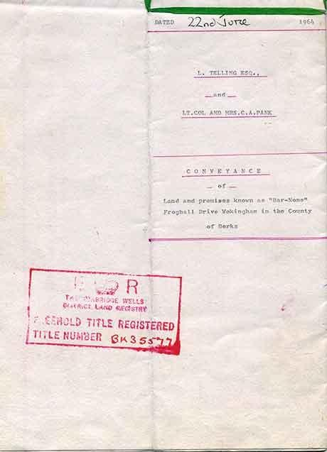

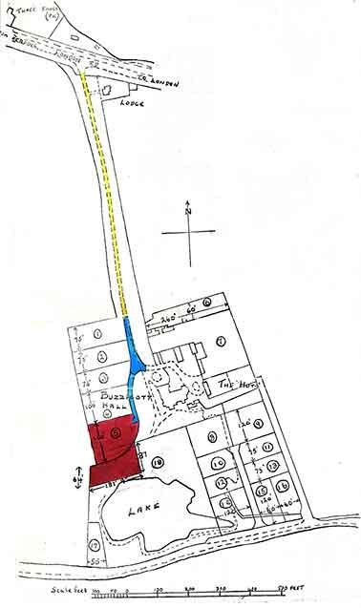

1955: Note that from 1946 until 1954 the hall was called Buzzacott Hall. In this map the Hall is not named, but probably had returned to its previous name. The pond where Tattersall Close is now is clearly marked.

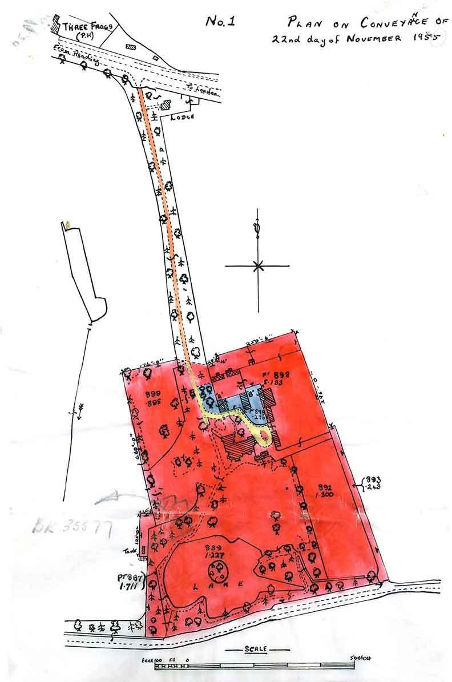

1940: The map is from a few years before the Hall was sold to Mr. Buzzacott.

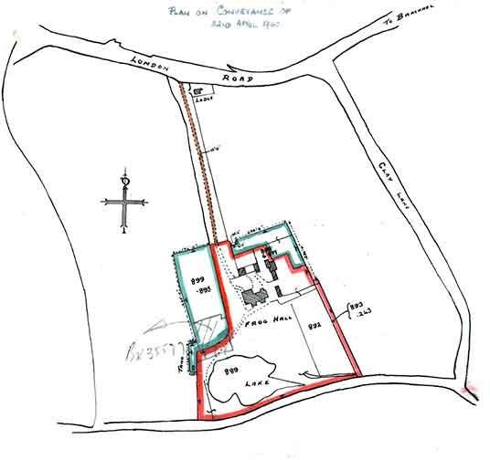

1939: Obviously little difference from 1940, but the shading makes it clear that the fields west, east and south of the gardens all used to form part of the estate.

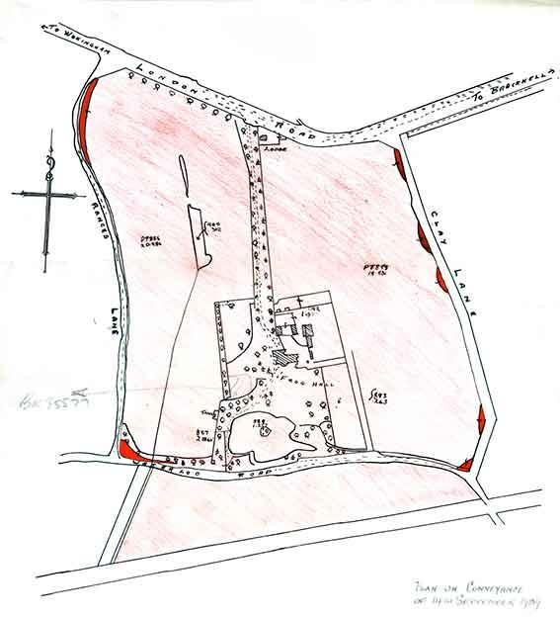

1922: The grounds of the hall have shrunk a bit now (although the estate remains as before).

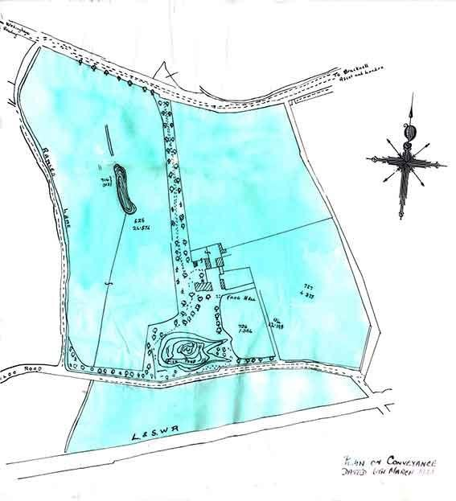

Public houses, inns, beer houses and breweries of Wokingham – 1901

Chris French, May 2020

Terminology
A public house (pub) is an establishment where alcoholic drinks may be served under licence for consumption on the premises.
An inn is traditionally a building where travellers can seek lodging and, usually, food and drink. Inns are typically located in the country or along a highway.
The distinction of a tavern from an inn, bar or pub varies by location, in some places being identical and in others being distinguished by traditions or by legal licence. In 16th century England, a tavern was distinguished from a public alehouse by dint of being run as a private enterprise, where drinkers were "guests" rather than members of the public. By 1900 the word tavern had developed an archaic flavour in Britain, the usual term being public house.

A History
On this page are the main locations in Wokingham known in 1901 to be concerned with the consumption of beer – alehouses, taverns, public houses and hotels. Where it has been possible to obtain information and photographs of the building in 1901 these have been given: where the building still exists today, a description and photograph of it in 2011 are also given, as a comparison.

Background
A group from Oxford University produced a document entitled 'An Account of Early Victorian Wokingham – Town and Parish' in 1984, based on data from the 1851 Census. The Wokingham U3A Local History Group decided to produce a follow-up document (Late Victorian Wokingham), based on the 1901 Census, following fairly closely the format of the original document and covering the situation 50 years on. I chose to take on the chapter entitled 'Inns, Alehouses and the Drink Trade'.
In the original document, this topic took only two pages. As a result of my particular interest in photography, I decided as a parallel activity to expand the topic and produce this document – gathering what I could in the way of photographic data from around 1900, and supplementing this with a comparative photograph of the building (or location) as it is today.

Introduction
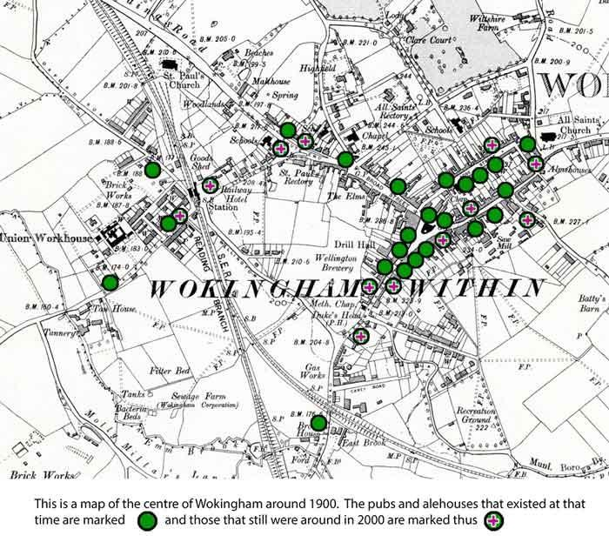
In 1830 a series of events began which were to change drastically the production and consumption of beer in Wokingham. Some events, like the Beer Act and the coming of the railway, were of
national importance; others, such as the enforced sale of Haywardʼs brewing empire were of more local significance.
The first of these events, the passing of the Beer Act in 1830, was an attempt by the government to wean the working classes away from gin drinking. It removed the duties on beer and cider so that once again beer became cheaper than spirits. In addition it allowed any ratepayer who paid two guineas (£2 2s) to the local excise office to sell beer from his house without having to obtain a licence from the magistrates. At the time beer was viewed as harmless, nutritious and even healthy.
The total number of beer houses and public houses known to have opened in Wokingham between 1830 and 1900 is 33. It is likely that perhaps half as many again opened and closed after a few years, all record of them having since been lost. The end of the century brought the total of licensed premises to 41, but in all the 70 years since the passing of the Beer Act only two new

houses had been opened with a full license, the Railway and the Rifle Volunteer, and the latter was a replacement for the Horse and Groom.
The Wine and Beer house Act 1869 reintroduced the stricter controls of the previous century.
The completion of the railway line from London to Reading in 1840 resulted in the total demise of the stage coach service from Bath and Bristol to London by 1843 and the loss of much trade by the inns along the Bath Road. A diminished service, however, continued between Reading and London via Wokingham with just one stage coach, S. William’s Windsor Park Coach calling at the Rose. The coming of the railway also had a considerable effect on Wokingham's licensed trade. The Railway was built next to the station by Hayward's Brewery. The opening of the South Western railway line to London in 1856 gave Wokingham a direct link to the capital. The Engineer (now the Two Poplars) initially relied on the construction workers for its custom. Overall, the railways brought more travellers to the town and a great impetus to the beer trade.

Public houses, inns, taverns and beer houses
- The Anchor - 37 The Terrace
- The Brewery Tap – 13 Broad Street
- The Bush Hotel - 37 Market Place
- The Cricketers – 29 Rose Street
- The Crispin – 45 Denmark Street
- The Crooked Billet – Gardeners Green
- The Crown – 29 Peach Street
- The Dog and Duck – Mathewsgreen Road, Emmbrook
- The Duke's Head – 1 Langborough Road
- The Eagle – 9 Rose Street
- The Fox and Hounds – Forest Road
- The Hope and Anchor – Station Road
- The Lord Raglan – 30 Denmark Street
- The Metropolitan – 58 Rose Street
- The New Leathern Bottle – Barkham Road
- The Pin & Bowl – Finchampstead Road
- The Plough – London Road
- The Queens Arms – 23 Rose Street
- The Queens Head – 23 The Terrace
- The Railway Hotel – Station Road
- The Red Lion – 25 Market Place
- The Redan – 24 Peach Street
- The Rifle Volunteer – 141 Reading Road
- The Rising Sun – 18 Oxford Road
- The Roebuck – 8 Market Place
- The Rose Hotel – 30 Market Place
- The Royal Exchange – 20 Denmark Street
- The Royal Oak – 3 Milton Road
- The Shades – 15 Broad Street
- The Ship – 104 Peach Street
- The Star – 56 Peach Street

- The Thatched Cottage - Emmbrook
- The Three Brewers – 3 Barkham Road
- The Three Frogs – 222 London Road
- The Two Poplars – 118 Finchampstead Road
- The Victoria Arms – 1 Easthampstead Road
- The Warren House – Forest Road
- The Welcome Inn – 33 Peach Street
- The Wellington Arms – 23 Denmark Street
- The Wheatsheaf – 14 & 15 Market Place
- The White Hart – 65 Rose Street
- The White Horse – Easthampstead Road
- The Who'd a Thought It – Nine Mile Ride
- The Wine Vaults – Market Place
- Ye Old Leathern Bottel – 221 Barkham Road
- Haywards Brewery – Reading Road
- Bakers/The Wokingham Brewery - Broad Street
- The Wellington/Headington Brewery – Denmark Street
- Eagle Brewery – 7 Peach Street

Closures
Between 1850 and 1901, at least 21 public houses, inns, taverns or beer houses closed down. They are listed below in alphabetical order, with the date last mentioned.

Name | Location | Last date
The Albion | Barkham Road | 1880
The Alma Arms | Reading Road | 1857
The Alma | Barkham Road | 1850
The Bee Hive | Emmbrook | 1900
The Brickfield Tavern | Spring Cottage Forest Road | 1854
The Bricklayers Arms | Rose Street | 1871

The British Workman | Market Place | 1881
The Dog and Partridge | Nine Mile Road | 1871
The Eagle | Peach Street | 1854
The Good Intent | Peach Street | 1854
The Horse and Groom | Reading | 1859
The Kings Head | Market Place | 1852
The Poor Man's Friend | Rose Street | 1851
The Red Cow | Market Place | 1884
The Robin Hood | Down Street ∗ | 1854
The Sedan Chair | Down Street ∗ | 1877
The Spotted Cow | Emmbrook | 1885
The Spotted Cow | Heathlands Road Gardeners Green | 1872
The Spread Eagle | Denmark Street | 1883
The Weldale Arms | Peach Street | 1871
The White Hart | Hones Green ∗∗ | 1854
∗Down Street became Denmark Street after the Princess of Denmark (later Queen Alexandra) who married Edward, Prince of Wales, in 1863.
∗∗ Hones Green is the Honey Hill/Gardeners Green area.

A Virtual Pub Crawl
Chris French presents a virtual walk around Wokingham's pubs, past and present.

Wokingham's pubs in detail The Anchor - 37 The Terrace Up to 1901
The Anchor Inn opened in 1777. In 1901 it was just 6 doors away from the Queens Head.
1901 to 2011
The inn closed in 1910 and is now a private house.
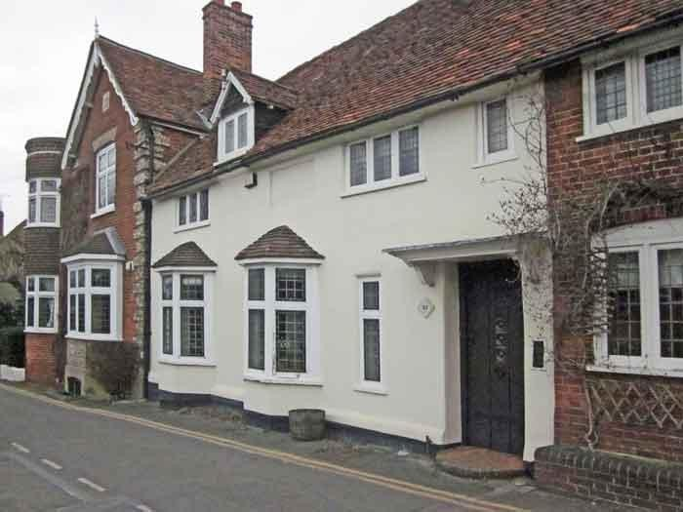
The Brewery Tap – 13 Broad Street
Up to 1901
The Brewery Tap was next door to The Shades and probably interlinked: they were both used as a direct outlet for the Wokingham Brewery, behind these buildings.
The Bush Hotel - 37 Market Place
Up to 1901
The timber-framed 15th and 16th century buildings that make up much of present-day Bush Walk were previously part of the Bush Inn. After being a stagecoach inn for 100 years, by 1901 it had become a hotel.

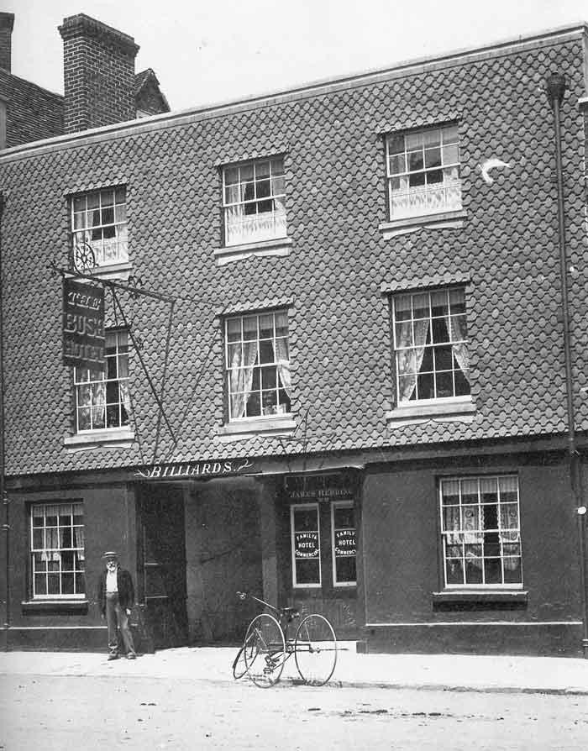
From: Wokingham – A Pictorial History / J&R Lea
1901 to 2011
The Bush Hotel closed in 1986 and has now transmuted into the Bush Walk shopping arcade. The pub-like sign is clear to see, although the design is very modern.

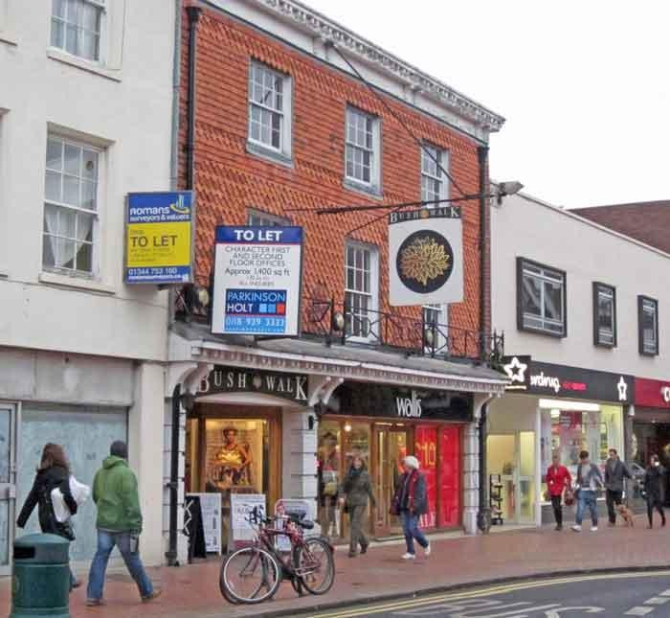
The Cricketers – 29 Rose Street
Up to 1901
The 15th century building in the foreground has had a variety of uses, including (from the start of the 20th century) that of a public house called The Cricketers. In this photo it had very recently been converted into a fish shop.

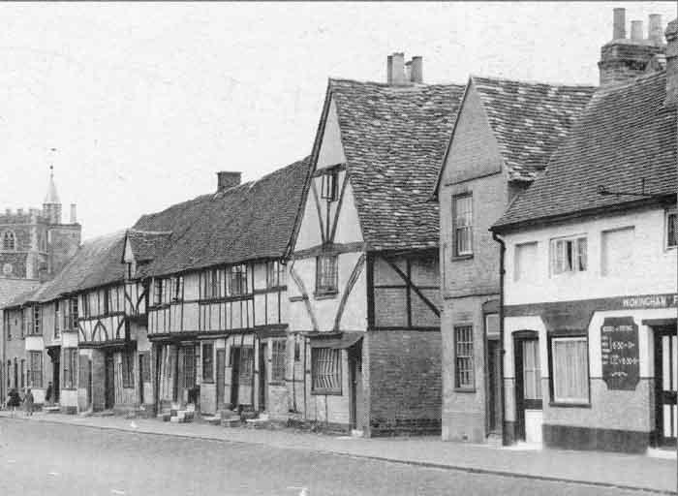
From: Francis Frith's Wokingham and Bracknell / Trevor Ottlewski
1901 to 2011
The chimneys and front elevation have not changed much since the previous photograph and the bracket for the pub sign remains intact.

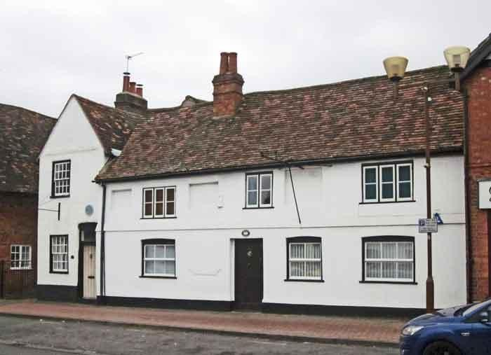
The Crispin – 45 Denmark Street
Up to 1901
The Crispin is one of the oldest buildings in Wokingham. It was built in the 15th century as a hall-house. This means it had a large central hall – the main room of the building – open to the roof, with a fire in the centre of the room. It was obviously the home of a prosperous man. In later times it was 'modernised', and an upper floor built across the full breadth of the house.
Some time later it was divided into three cottages. By 1854, the owner of the central cottage (James Green) had become sufficiently prosperous as a 'brewer and beer seller', to buy out the other two owners and use the whole building as an inn.

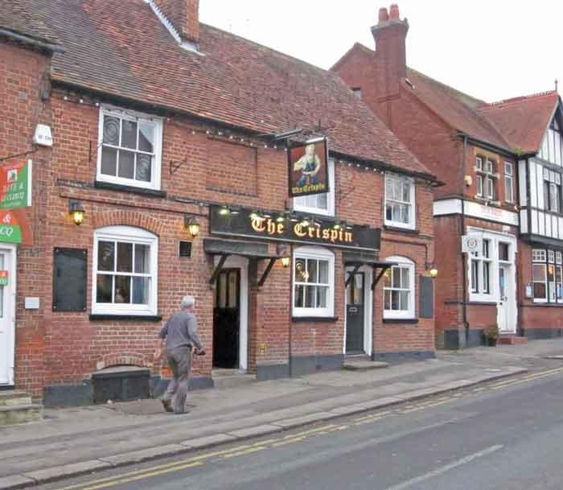
1901 to 2011
The Crooked Billet – Gardeners Green
Up to 1901
The pub name is capable of various interpretations, but the sign depicts a small twisted log of wood.
There was a story that the house once stood on the other side of the road and that it was moved to avoid being flooded by the nearby Emm Brook. Although it is possible that a timber-framed building could be moved, it is unlikely. It is more likely that the road was diverted to pass on the other side of the building. Whatever happened, if it did, was early in the 19th century and no sign of diversion has been found.

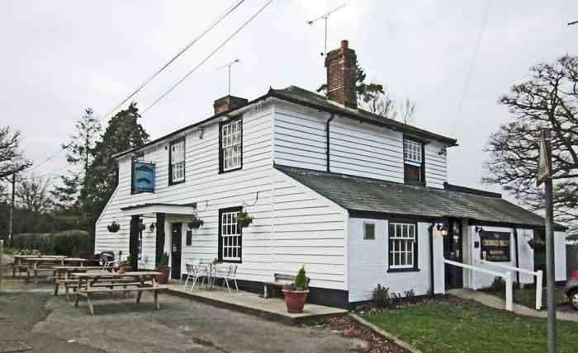
1901 to 2011
The Crown – 29 Peach Street
1901 to 2011
This parade of shops, including the ex-Woolworths store to the right, was redeveloped in the 1930s.

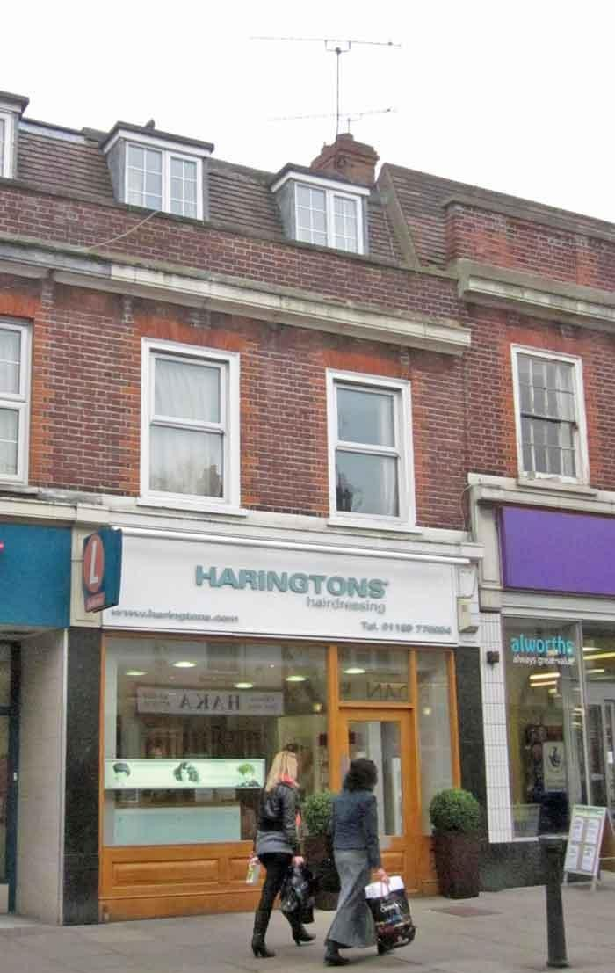

The Dog and Duck – Mathewsgreen Road, Emmbrook
Up to 1901
The Dog and Duck at Emmbrook started life as a beer house. Absolom Deane received the first licence in 1851 when he was 80 years old (and described in the census as a gardener). Brakspears Brewery bought it in 1857 and by 1901 it was an attractive public house in a rural setting.
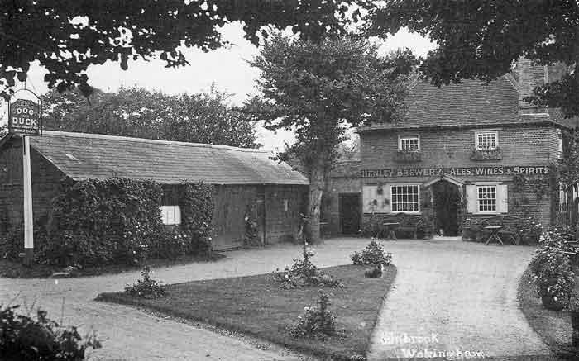
From: Wokingham – A Pictorial History / J&R Lea
1901 to 2011
The sign now shows a black dog, thought to be an Irish water spaniel, gazing up at a duck in flight.

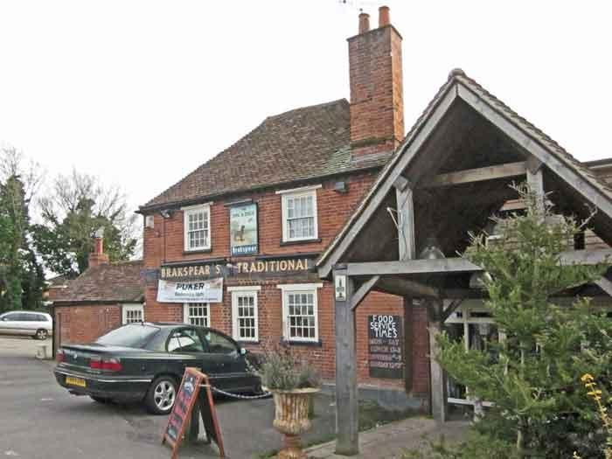
The Duke's Head – 1 Langborough Road
Up to 1901
Originally 3 cottages, the Duke's Head was first mentioned as a public house in 1795.

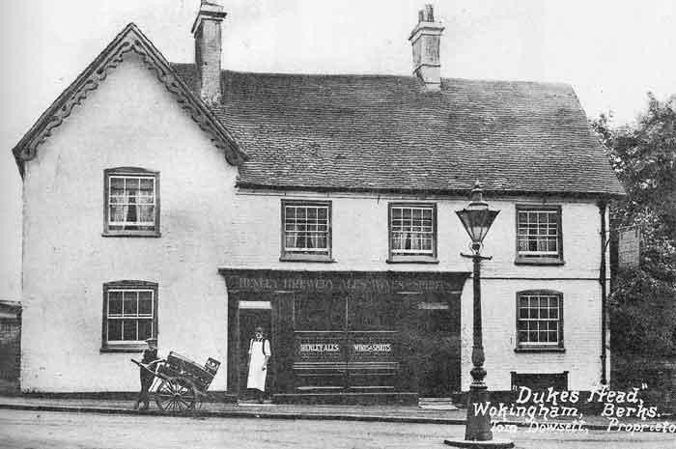
From: Wokingham – A Pictorial History / J&R Lea
1901 to 2011
The two entrance doors of 1901 have been blocked up and a modern entrance made on the left of the building.
The yard of the present public house contains a 200-year old building, now restored for use as a skittle alley.

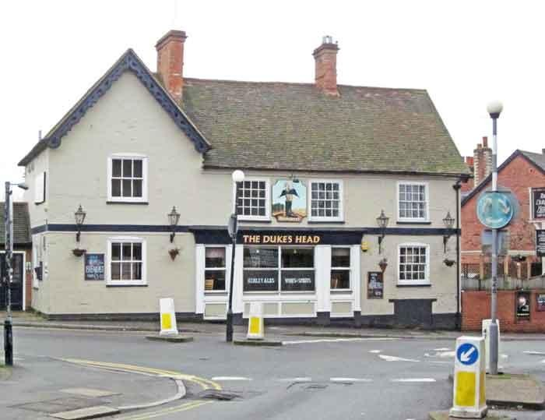
The Eagle – 9 Rose Street
Up to 1901
The Eagle was a retail outlet for the small Eagle brewery, on the same premises. It was later renamed The Bear.
1901 to 2011
All that remains of the site is now hidden behind the walls of the car park.

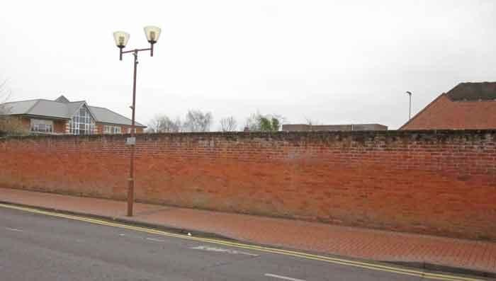
The Fox and Hounds – Forest Road
1901 to 2011
The Fox and Hounds, situated on Forest Road and quite close to the Warren House, is now a private cottage.
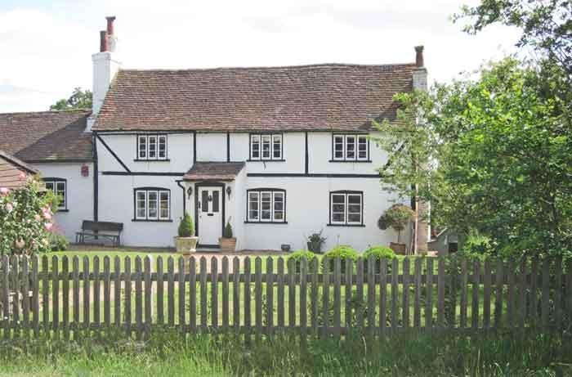

The Hope and Anchor – Station Road
Up to 1901
The right hand side of the Hope and Anchor still occupies this 15th century hall-house, while the other end of the bar was formerly a smithy, but this was not built until the second half of the 19th century, after the pub had been in existence for some years. The garage and entrance to the garden were also built about the same date. It was built in 1840 and in 1901, at the time of this photograph, it was owned by Baker, Powell and Co., the Wokingham Brewery that was based in Broad Street.
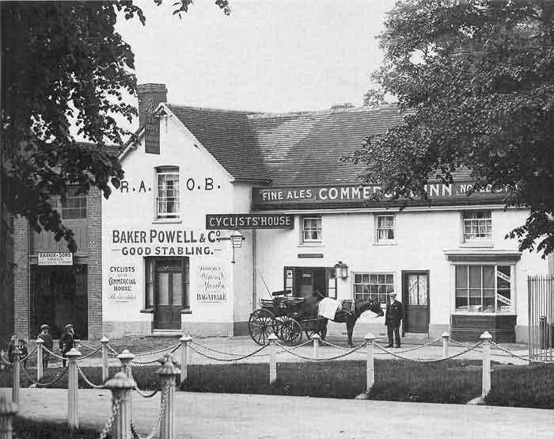
From: Wokingham – A Pictorial History / J&R Lea
1901 to 2011
The Hope and Anchor as it is today at the top of Station Road opposite the Council offices.

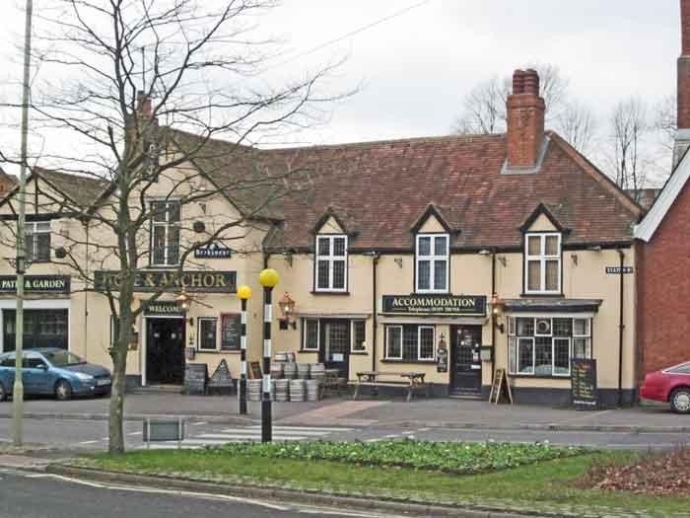
The Lord Raglan – 30 Denmark Street
Up to 1901
The building began as three cottages built in the early 19th century. Thomas Searle was the landlord from 1830, when it was a one-roomed alehouse, until his death in 1887, by which time it was an inn with five bedrooms.
1901 to 2011
Despite its humble beginning, the building is a listed one. However the inside of the house has been extensively altered and opened up so that today it bears little relationship to the original interior.

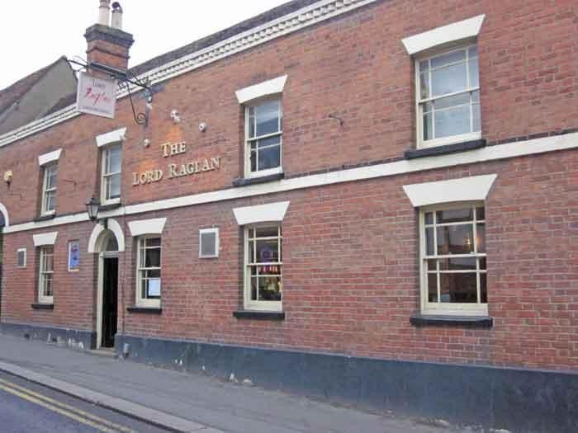
The Metropolitan – 58 Rose Street
Up to 1901
This photograph shows the landlord and some of his customers outside the Metropolitan beer shop in Rose Street. The owner is wearing the bowler hat and shirtsleeves. The building is a 15th century hall-house, modified over the centuries to meet the needs of its owners.

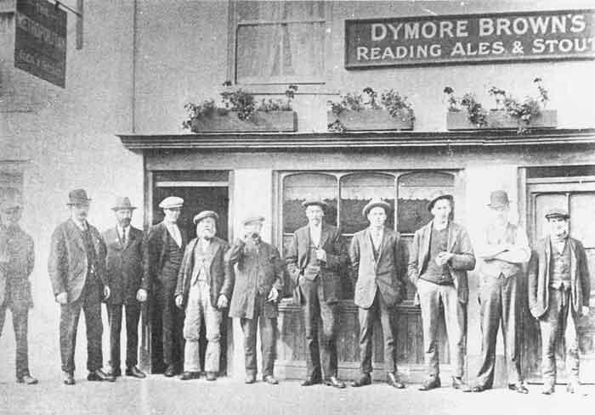
From: Wokingham – A Pictorial History / J&R Lea
1901 to 2011
The sign shows a guardsman, standing against a London background. No satisfactory explanation has been put forward as to the origin of the name. Most probably it was the whim of an individual landlord.

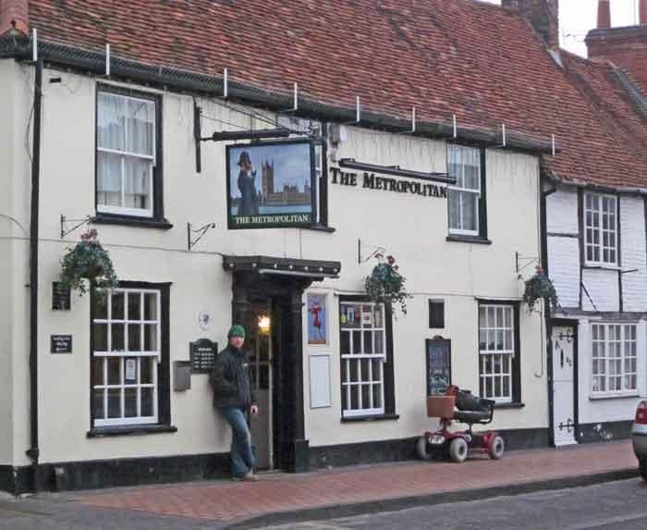
The New Leathern Bottle – Barkham Road
Up to 1901
The New Leather Bottle was a short-lived beer house (c.l870 — c.1911) at Sand Pits, on the Barkham Road, on the Walter estate; sometimes confused with a separate establishment, the Old Leathern Bottle (or 'Bottel' as it's now named) that was about 400 yards away.
The Pin & Bowl – Finchampstead Road
Up to 1901
Probably built in the 16th century, the establishment underwent many changes over the years –
beer was being brewed here in 1722 and sold here in an alehouse here in 1740.

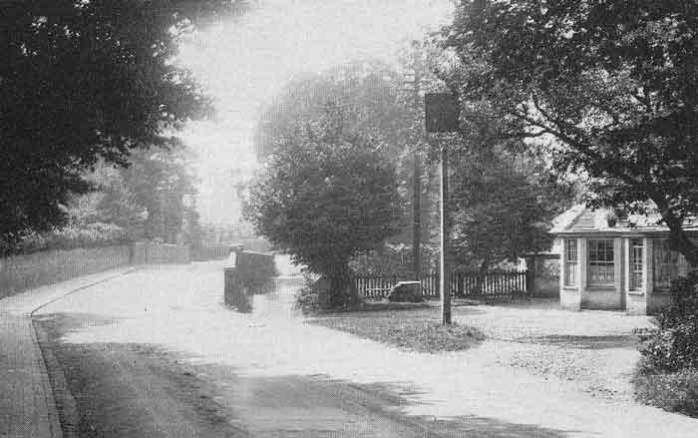
Britain in Old Photographs - Wokingham / Bob Wyatt
1901 to 2011
The Pin and Bowl closed in 1992 and was demolished shortly afterwards, in 1995, when this small shopping complex was built. At the time it closed it was probably the smallest public house in Wokingham. The latest Barnett's street map of Wokingham still includes the Pin and Bowl, showing its former position.

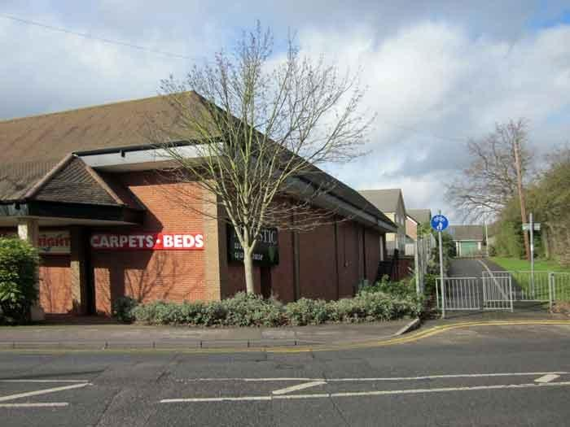
The Plough – London Road
Up to 1901
The earliest known licensee, in 1850, was Charles Johnson; within a year his wife had taken over the licence. Like so many other small pubs the income from it was too small to support a family and Charles had become a mailman. Two years later the Johnsons had gone and the licensee was Thomas Rance, the first of the Rance family who were to run the Plough until 1911. The family are thought to have given their name to the nearby Rances Lane. The original Plough was a beer shop, sited just round the corner from the present building – on Plough Lane, rather than fronting onto London Road.
1901 to 2011
The current building was built in 1924 and until 2006 the Plough continued as a public house, but has now been converted into a restaurant.

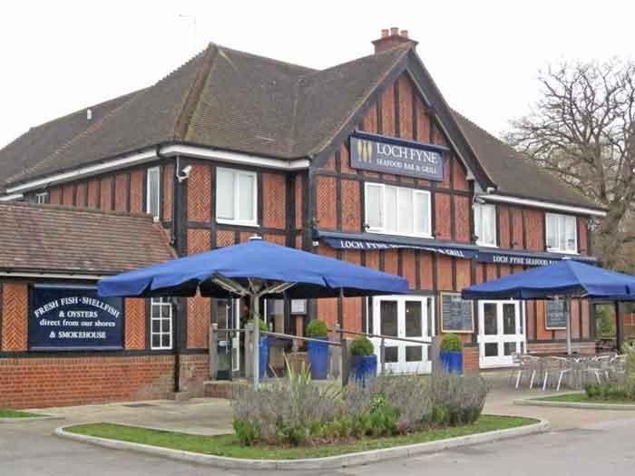
The Queens Arms – 23 Rose Street
1901 to 2011
The support for the inn sign can still be clearly seen.

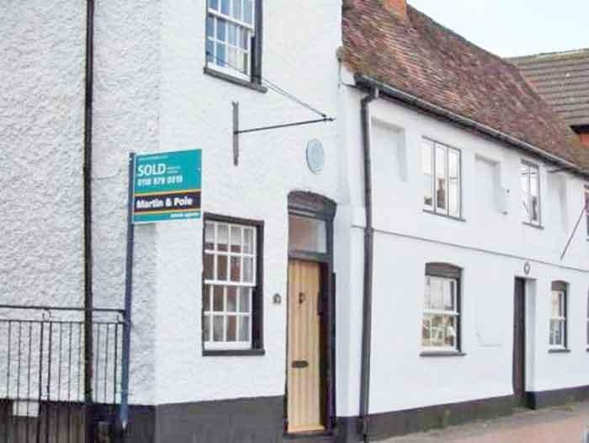
The Queens Head – 23 The Terrace
Up to 1901
Looking along the unmade surface of Shute End, past The Terrace, on which stands The Queen's Head.

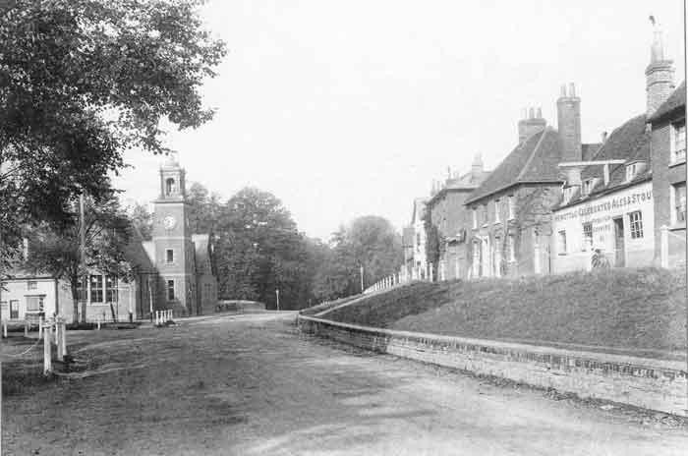
From: Francis Frith's Wokingham and Bracknell / Trevor Ottlewski
There is no mistaking the service offered by this establishment. The building, which dates from the 15th century, is notable as the only building in Wokingham known to have a cruck frame as part of its construction, a feature that is relatively common in Northern England, but less so in the South-East; only seven buildings with this form of construction are known in Berkshire.

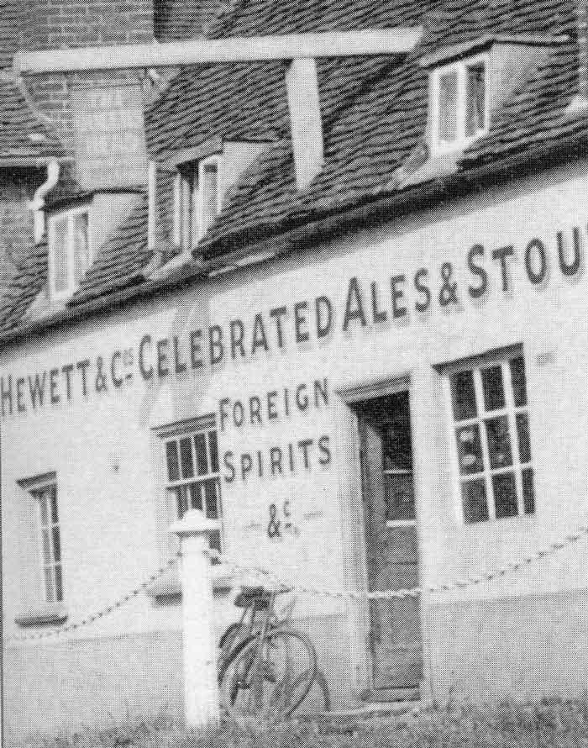
1901 to 2011
Much remains the same today, including the unusual support for the inn sign and the dormer windows.

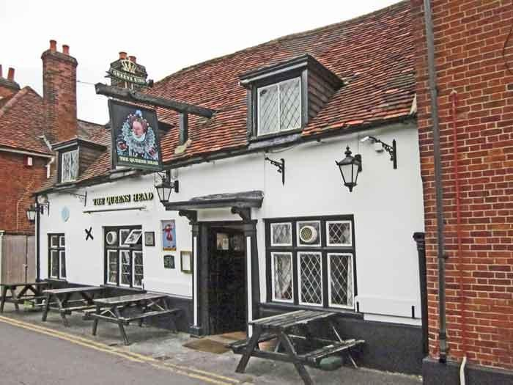
The Railway Hotel – Station Road
Up to 1901
This is Station Road, looking up the hill towards The Terrace from the railway crossing. The Railway (as it was initially named in 1849) became first the Railway Tavern and then the Railway Hotel, as its fortunes flourished. In 1856 it was bought by the Wokingham Brewery. By 1901 it had a larger trade than the Rose Hotel. An annex, the Railway Tap, was opened at the back for those customers who were not as wealthy as the main patrons of the hotel.

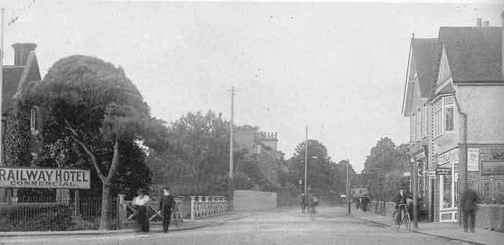
Britain in Old Photographs - Wokingham / Bob Wyatt
This view also shows the Railway Tap, on the left – well out of sight and earshot of the hotel guests.
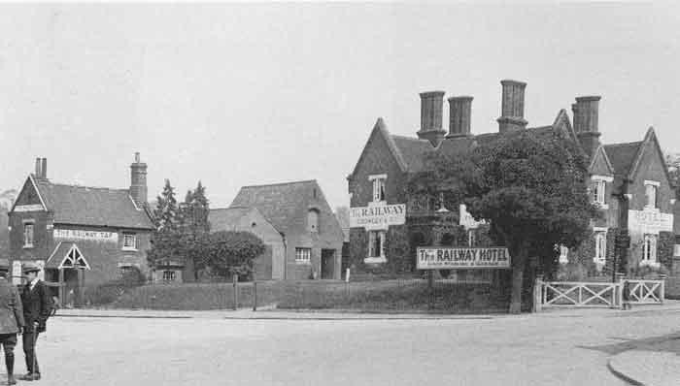
1901 to 2011
The prestigious Railway Hotel has now become the Molly Millar and has been 'demoted' to a pub.

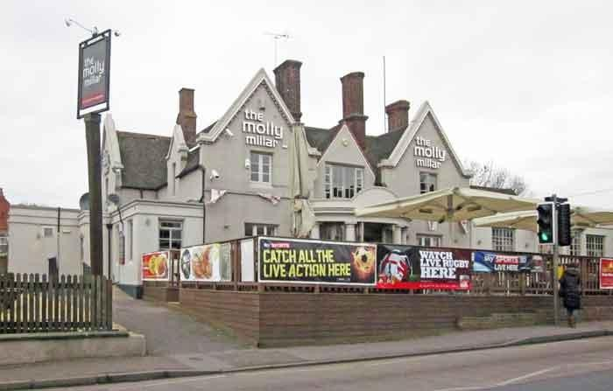
The Red Lion – 25 Market Place
Up to 1901
The Red Lion is one of the oldest buildings in Wokingham. However, seen from along Red Lion Path it is obvious that the pub is made up of a number of buildings of different ages.
1901 to 2011
The entrance to the stables at the rear can still be clearly seen.

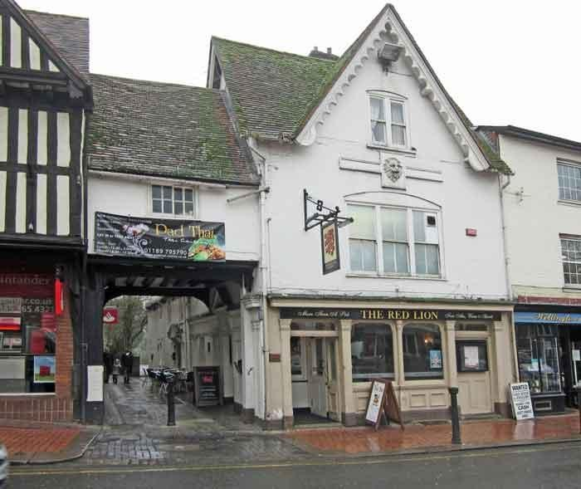
The Redan – 24 Peach Street
Up to 1901
This is one of the new buildings in this area of Wokingham, which later became the Redan, and it was originally built in 1842 as part of the development on the site of Hall's Academy, a former private school. The inn itself was rebuilt in 1869. Richard Arnold was the licensee in 1901, but in 1903 he lost his licence and was fined 40 shillings and costs at the Brewster Sessions for permitting drunkenness.

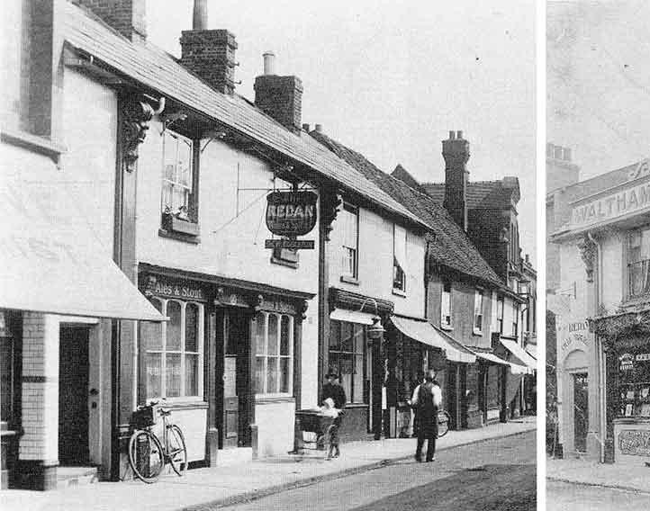
Britain in Old Photographs - Wokingham / Bob Wyatt
1901 to 2011
The Redan as it is today.

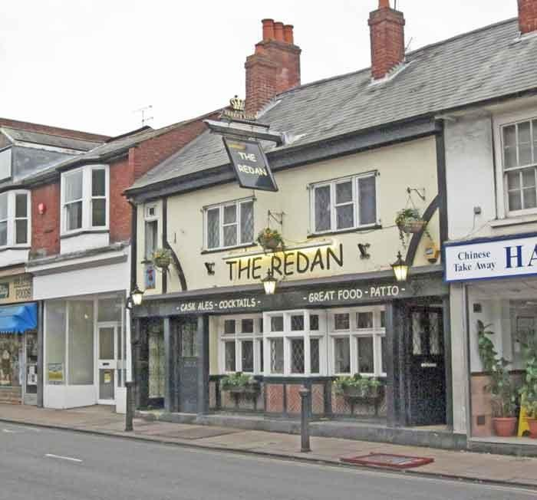
The Rifle Volunteer – 141 Reading Road
Up to 1901
The peace and quiet of this scene by the Rifle Volunteer on the Reading Road have vanished forever, leaving only the public house as a reminder of times past. Originally just 'The Volunteer', it replaced an earlier public house called The Horse and Groom. In 1901 it belonged to Nicholsons Brewery of Maidenhead.

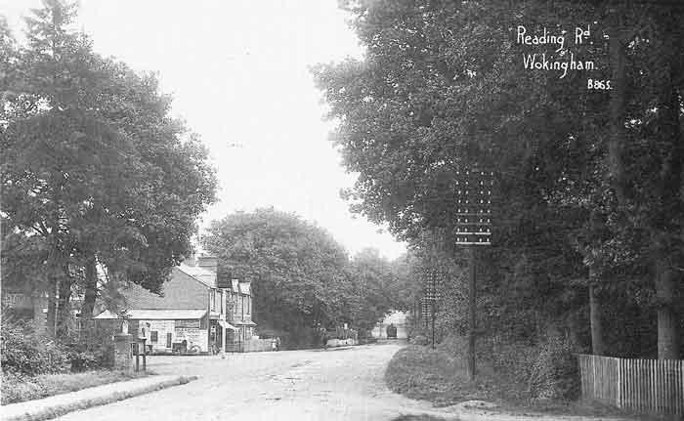
From: Wokingham – A Pictorial History / J&R Lea
1901 to 2011
Today, although it retains the name it has been extensively refurbished, and there is a minor industrial estate behind the public house.
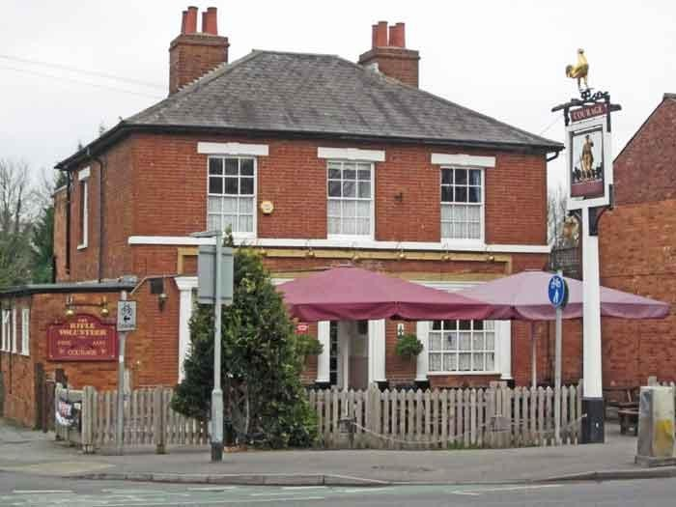

The Rising Sun – 18 Oxford Road
1901 to 2011
(We have no earlier photos of this establishment.)
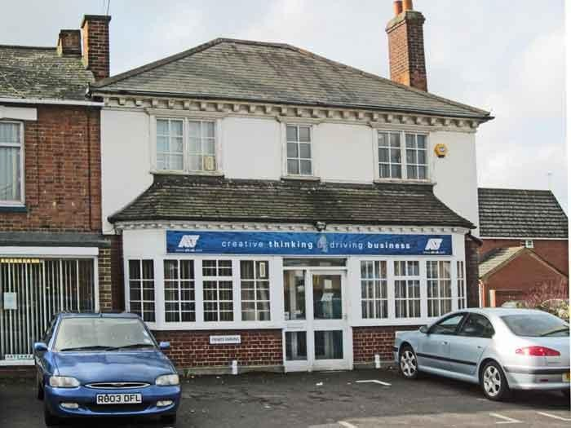
The Roebuck – 8 Market Place
Up to 1901
The Roebuck is a 16th century house that was enlarged and modified in the 16th and 20th centuries. A part of the building next to the coach entrance has been used as a shop since early in the 20th century; prior to that time the frontage of the inn was almost double its present width.

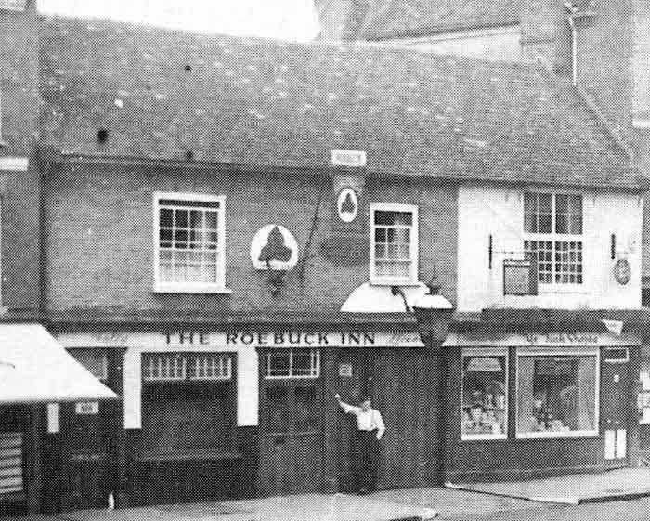
From: Wokingham – A Pictorial History / J&R Lea
1901 to 2011
The Roebuck has now been turned into a bar and grill, the 'Square One'. The coach entrance is still visible.

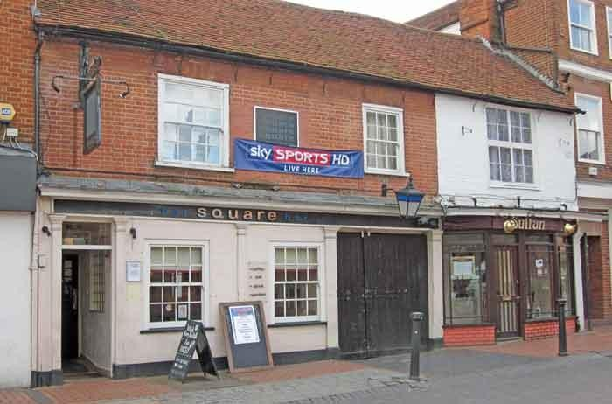
The Rose Hotel – 30 Market Place
Up to 1901
The original Rose Inn stood on the north side of Market Place. It ceased being used as an inn in 1844, at which time the current owner moved to the other side of Market Place, to its present position. This was because John Wise wanted to provide 'better accommodation and comfort for the nobility, gentry and public'. The Rose Hotel (as it has been since 1920) was once two buildings, but was then extended to provide extensive stabling, a lock-up coach house and a large garden at the rear. It has been one of the centres of Wokingham life ever since.
[The New Rose was an inn in Peach Street, which lasted only a dozen years, around 1770-1780)].

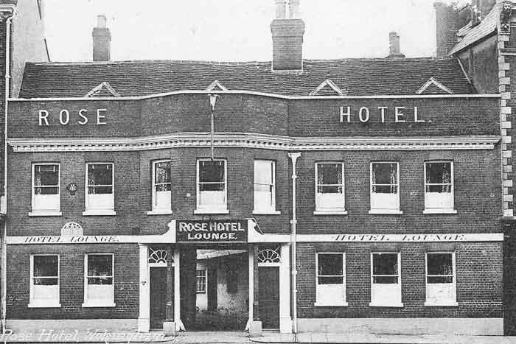
From: Wokingham – A Pictorial History / J&R Lea
And this is a photograph of the hotel from the back.
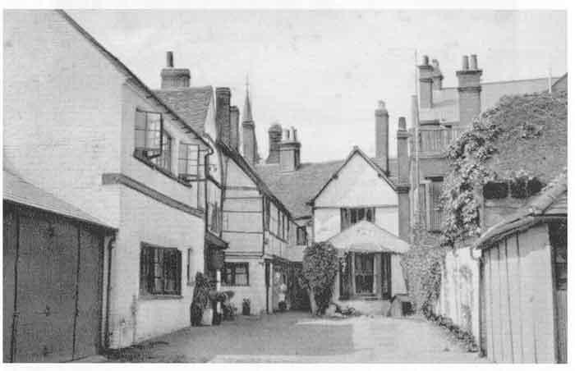
Britain in Old Photographs - Wokingham / Bob Wyatt
1901 to 2011
The name 'The New Rose' lasted until 2010 when, despite the sign remaining over one of the disused entrances, it effectively became a bar/grill called the Café Rouge.

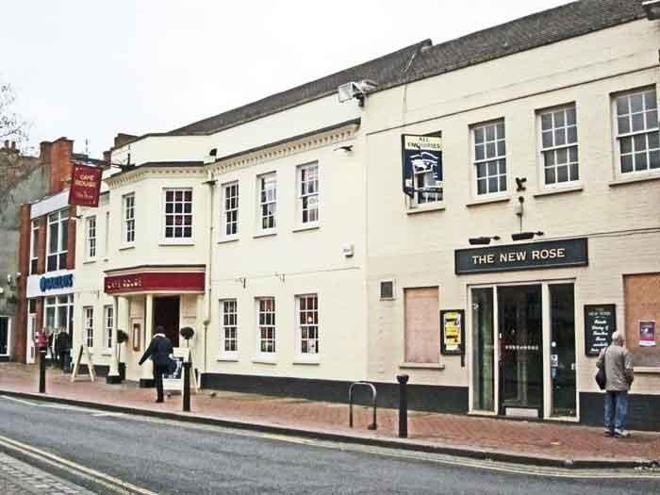
The Royal Exchange – 20 Denmark Street
Up to 1901
The Royal Exchange can be seen on the right. The advertisement shows that it was owned by Simmonds Brewery at the time.

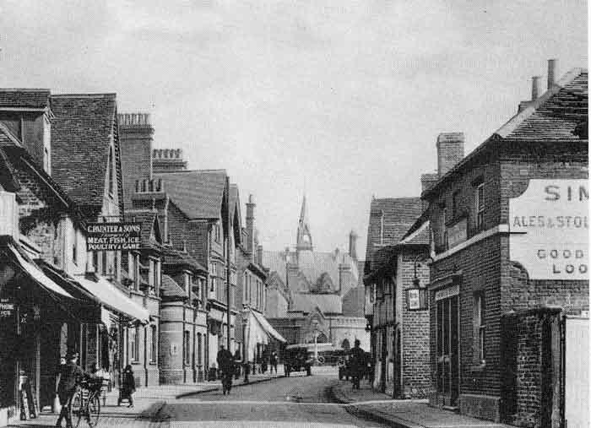
Britain in Old Photographs - Wokingham / Bob Wyatt
1901 to 2011
The location is now a shop and office space.

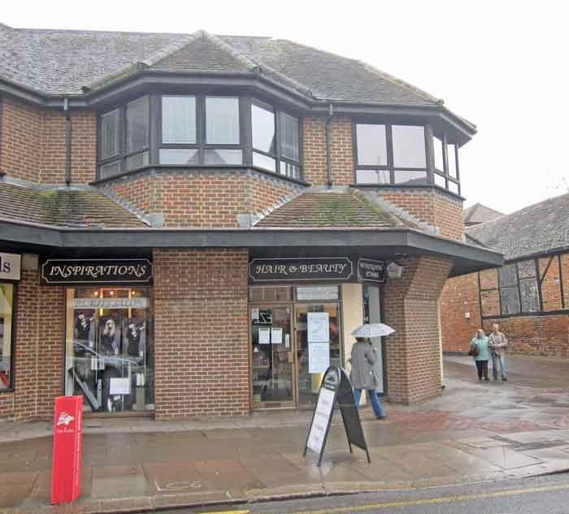
The Royal Oak – 3 Milton Road
Up to 1901
The Royal Oak was round the corner from the old Police Station. It closed in the mid-20's and was demolished some years later.
1901 to 2011
The location is now a grass area and turning circle.

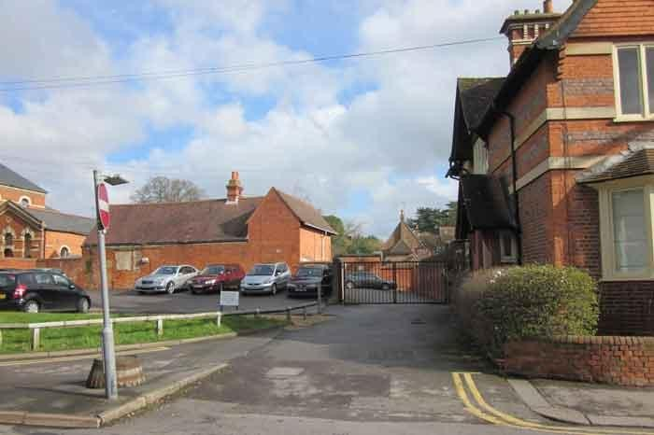
The Shades – 15 Broad Street
Up to 1901
The Shades was a beer house, opened in 1851 after some local opposition from other breweries and the well-to-do residents of Broad Street, in the front of Bakers/The Wokingham Brewery in Broad Street. Rosalind Baker, a member of the brewing family, lived at the Shades.
1901 to 2011
The Shades is now an estate agent.

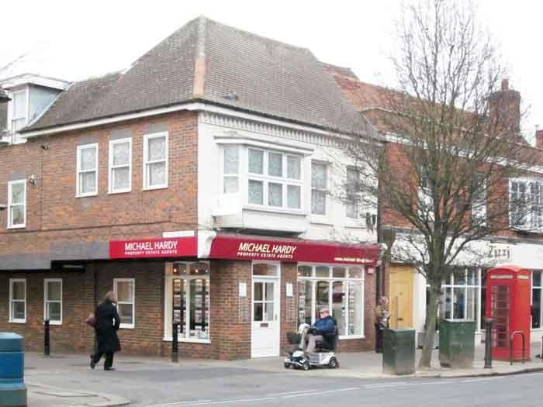
The Ship – 104 Peach Street
Up to 1901
The oldest part of the present Ship is the 17th century timber framed building at the corner of Peach Street and Wiltshire Road. It has been much altered; the original outer walls having been replaced with brick while many of the internal walls have been removed.
1901 to 2011
Today, some of the original beams can still be seen in the bar, together with a number of replicas, steel girders covered with wood, where walls have been removed. The western part of the building was a blacksmith’s shop while part of the building and part of the car park occupy the site of three of the l5th century Westende almshouses.

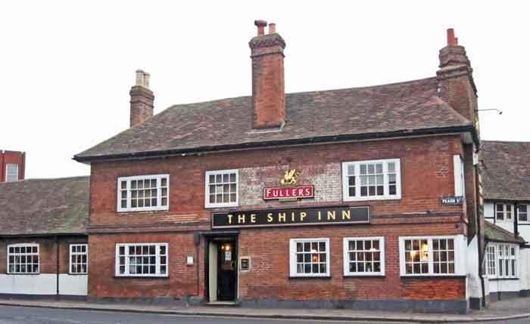
The Star – 56 Peach Street
Up to 1901
The Star Inn was directly opposite what is now known as Easthampstead Road, but what was until 1886 known as Star Lane (hence the Star Lane railway crossing).
1901 to 2011
The inn closed in 1909 and has since been demolished and its site taken over by this parade of 'modern' shops.

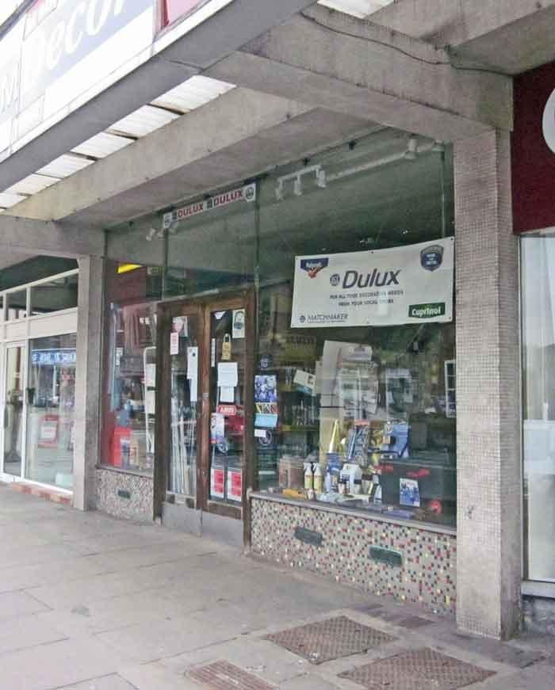
The Thatched Cottage - Emmbrook
Up to 1901
The original public house was a thatched cottage, which was probably built in the early 19th century. It was bought by Simonds, the Reading Brewer, in 1866 and rebuilt just before 1901.

1901 to 2011
The Thatched Cottage still exists as a pub, but now officially under the name of the 'Emmbrook Inn', although Googling the old name still turns up many results and Barnett's street map still uses the previous name.
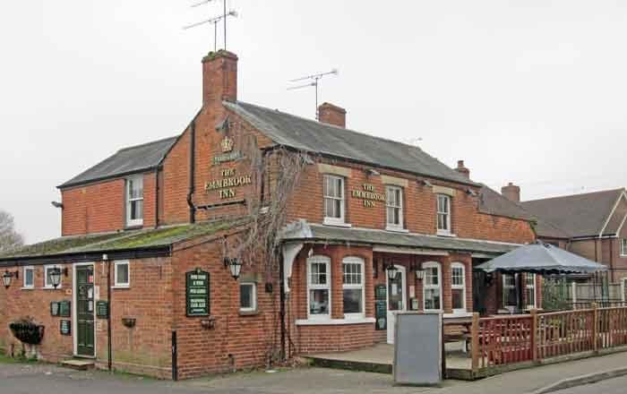
The Three Brewers – 3 Barkham Road
Up to 1901
The building started as an alehouse in the 1850s and by 1869 was owned by the Simmonds Brewery.

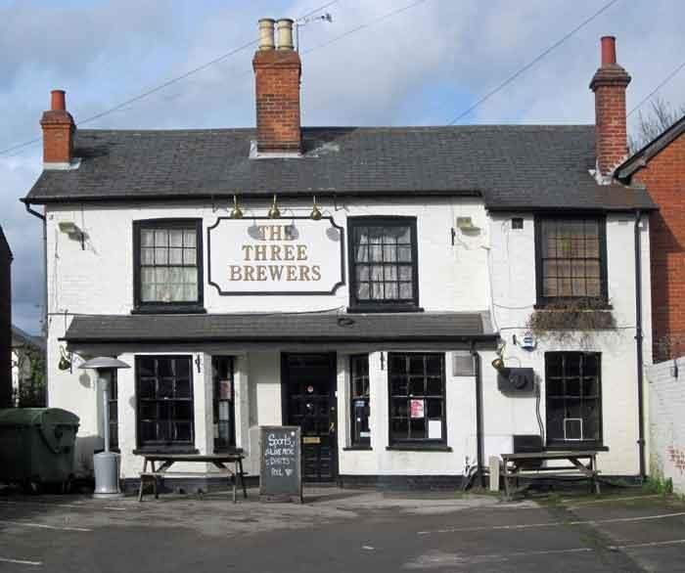
1901 to 2011
The Three Frogs – 222 London Road
Up to 1901
Although this public house was once a private house known by the name of Frog Hall, it has been so much altered, particularly in recent years, that it is hard to see any thing of the original building.
Although it has been called the Three Frogs for over two hundred years, no one has yet been able to conclusively find out the origin of this name. The most plausible suggestion is that the name was derived from Frog Hall. In turn the hall was thought to have been named after the animals themselves, which abounded in the area because of its former boggy nature.
By 1823 it was owned by Haywards Brewery.

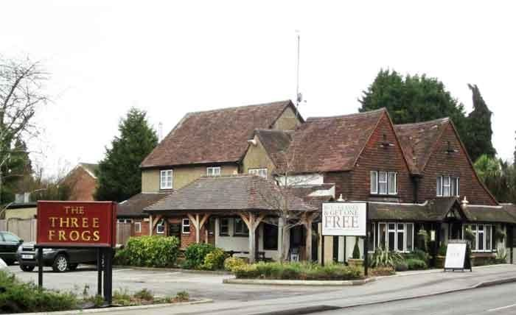
1901 to 2011
The Two Poplars – 118 Finchampstead Road
Up to 1901
The building is on the site of an earlier building and then was rebuilt or at least extensively altered in the 1850s, probably at the time it was first used as a beer house. Recent additions dwarf the older structure.
The Two Poplars was originally a beer house catering for the workers building the railway from Guildford to Reading. The beer house was at first called the Engineer, and then the Engineer’s Arms, or lngineers’ Arms. Sometime before 1880 the name had changed to the Two Poplars.
It was leased to various breweries before being sold to Henry Hewlett of the Waltham St. Lawrence brewery in 1888.

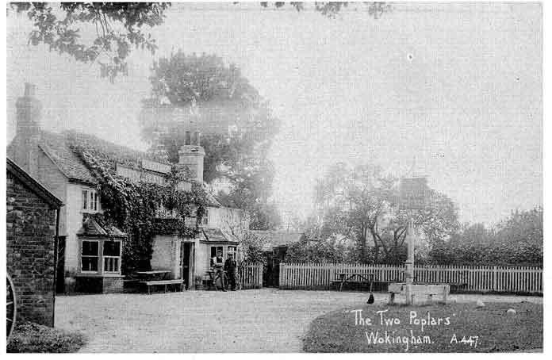
Britain in Old Photographs - Wokingham / Bob Wyatt
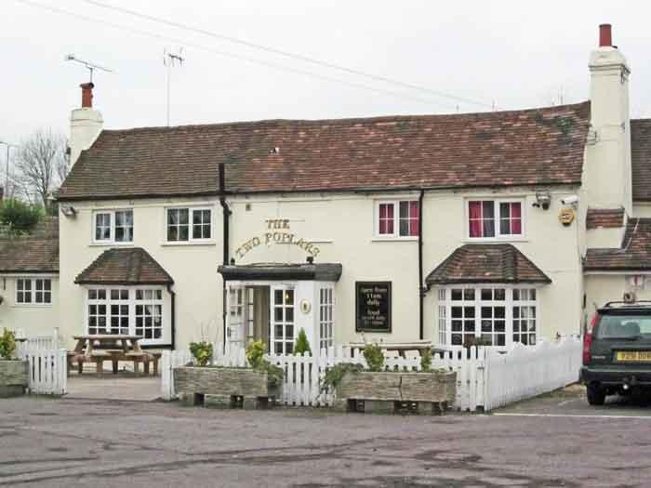
1901 to 2010

The Victoria Arms – 1 Easthampstead Road
Up to 1901
The original house was one of a pair of late 18th century brick tenements in Easthampstead Road, then known as Star Lane. In 1847 the beer house was bought by Hewetts Brewery.
In l85l Henry Baldwin bought the adjacent property and expanded his main business, building coaches, not merely their wheels. The business flourished, but in 1861 it was sold to George Lush. George Lush did so well that within a few years he was supplying coaches to the Royal Family. The pub and the coach-building firm were run by the same family until 1907. The last licensee and coachbuilder was Frank Lush.
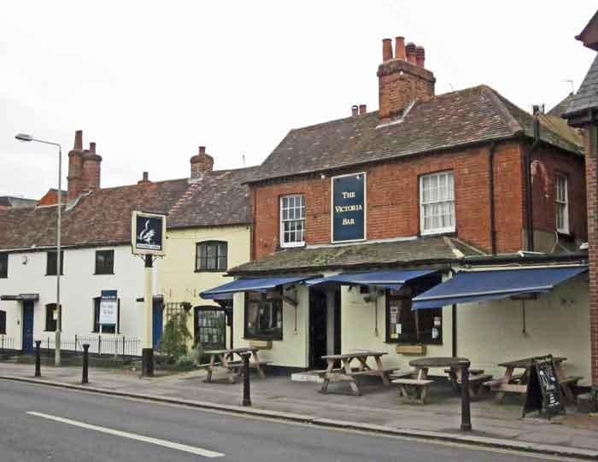
1901 to 2011
The Warren House – Forest Road
Up to 1901
The name is derived from Warren House, the name of the farm that stood on the site as early as 1681. In turn the farm probably took its name from a medieval rabbit warren, which is thought to have existed in this part of Wokingham; owning a warren was then a privilege.
The first known reference to the building as a public house is in an advertisement in the Reading Mercury of 15th November 1777, which announced a pigeon shoot "at the Warren House, Mr Calloway’s".

The name appears to have varied more than that of any other public house in the Wokingham district. After the change to the New Warren House in 1817, it changed back to simply Warren House before 1820, only to become the Warren Inn by 1824. In the 1830s and early 1840s it was known as the Warren House, only to become the New Warren House by the 1850s, which name remained in use until recently. Today it is once again the Warren Inn, although there is no evidence that the traditional functions of inn-keeping were ever carried out there!
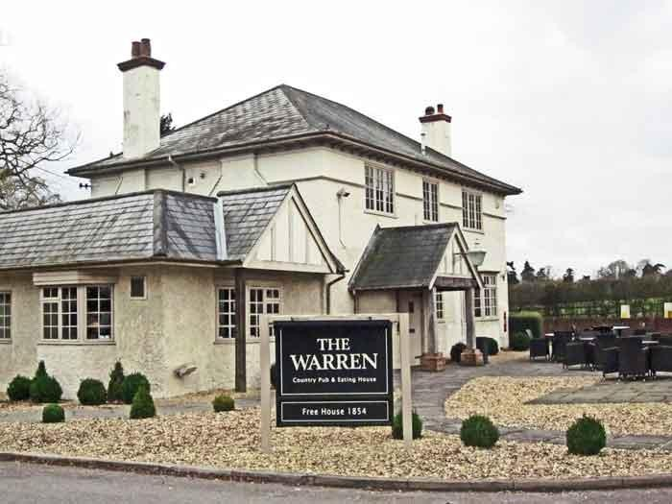
1901 to 2011
The Welcome Inn – 33 Peach Street
Up to 1901
The Welcome Inn started trading in 1850.
1901 to 2011
This parade of shops, including the ex-Woolworths store, was redeveloped in the 1930s. By the early 1960s the pub had closed and is now a hairdressers.

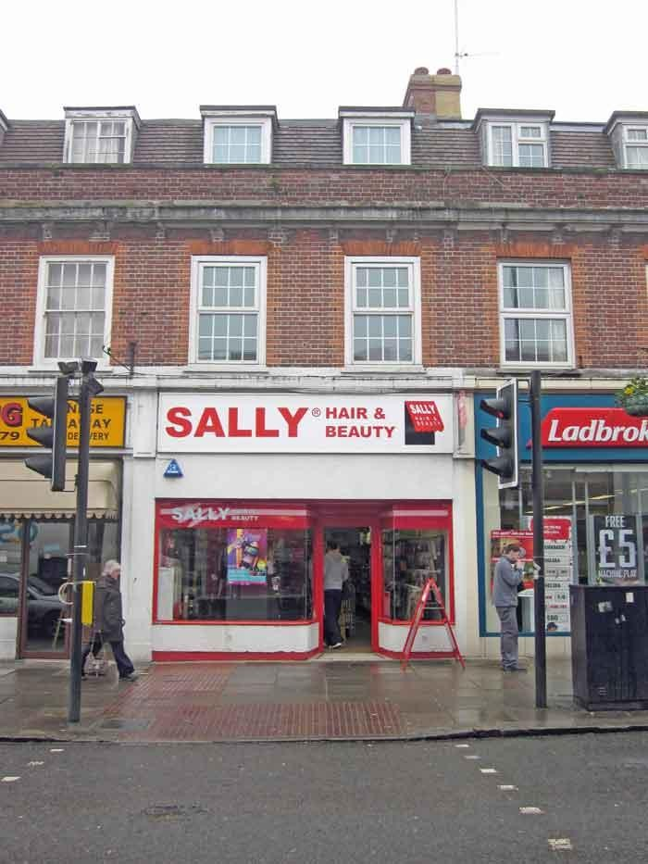
The Wellington Arms – 23 Denmark Street
Up to 1901
In 1856, when the Haywards empire was being split up, Robert Trickey Dunnings bought The Chair in Denmark Street. The Chair later became the Duke of Wellington, the Wellington Stores and

finally the Wellington Arms. He also bought land behind the Chair upon which he built the

Wellington Brewery.
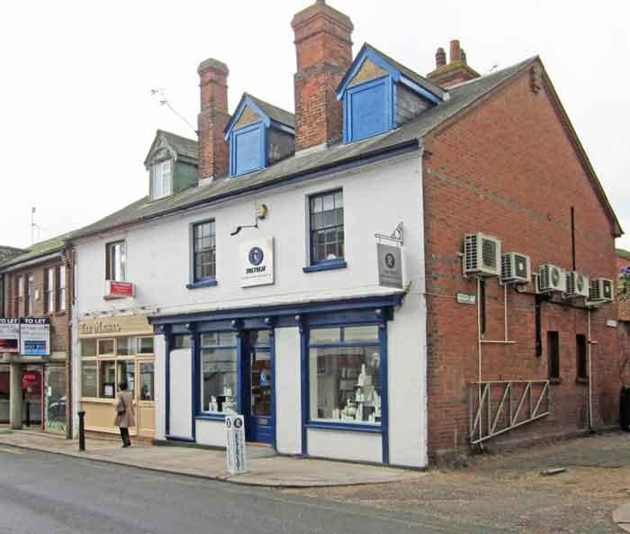
1901 to 2011
The Wheatsheaf – 14 & 15 Market Place
Up to 1901
This is a view from Market Place looking down Denmark Street. The Wheatsheaf Inn is an early 19th century building. As can be seen it was not tied to a brewery, selling both Allsopps Ales and Stollery Brothers wines and spirits.

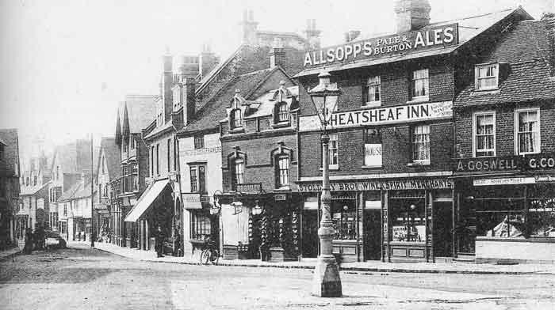
From: Wokingham – A Pictorial History / J&R Lea
1901 to 2011
The building is now occupied by a branch of Fat Face.

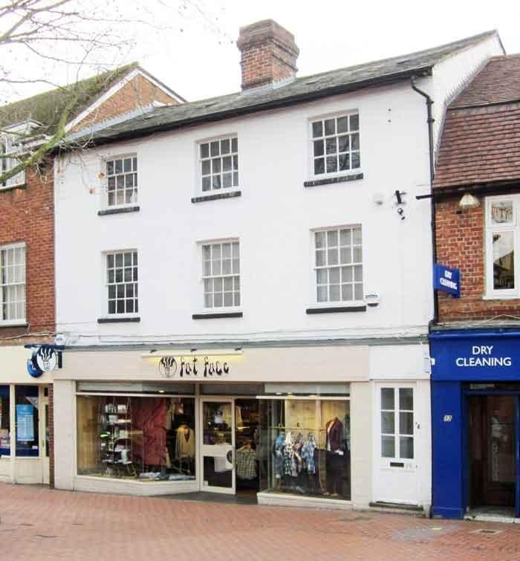
The White Hart – 65 Rose Street
Up to 1901
In 1901 this was one of 7 public houses in the short length of Rose Street. It was the home of the Rose family.

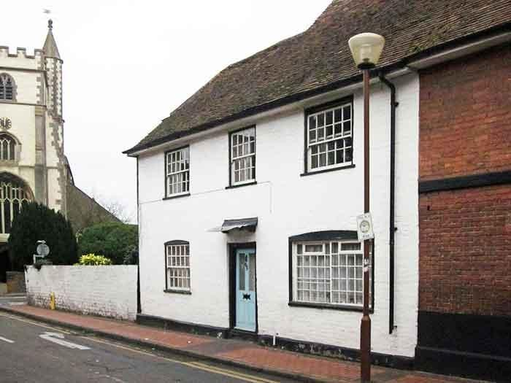
1901 to 2011
The White Horse – Easthampstead Road
Up to 1901
In 1882 Hewett’s Brewery built the current building, which fronted directly onto the Easthampstead
Road.

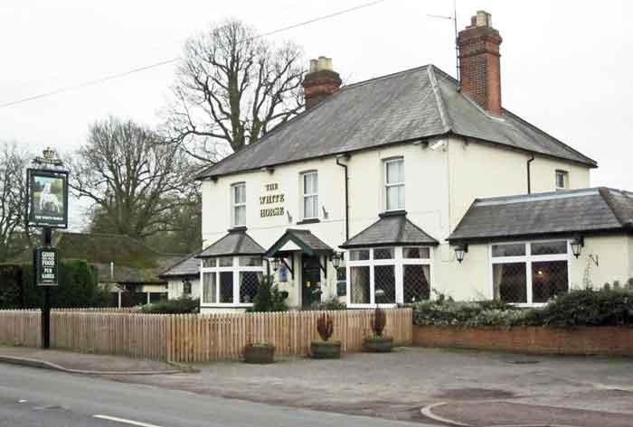
1901 to 2011
An earlier original alehouse is the small brick built house, now 'White Horse Cottage', just to the right (north) of the 'new' public house.
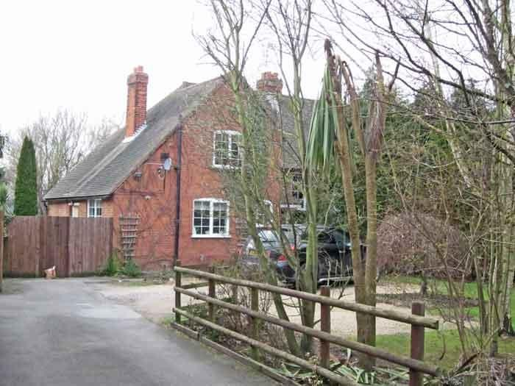

The Who'd a Thought It – Nine Mile Ride
Up to 1901
The unusual name, first recorded in 1861, is said to have originated in a remark by the Duke of Wellington. The story goes that travelling in the forest one day and feeling very thirsty he suddenly came across the pub. His exclamation ’Who’d a thought it' became the name of the pub. It is an unlikely story since there are several other pubs by the same name in other parts of the country and the pub wasn't open when Windsor Forest existed.
According to the historian Bryant Lily-White, the name is thought to have been taken from the suggestion of a wag that the motto to the coat of arms of a certain baronet-brewer should be:
Who'd a thought it? Hops had bought it.
1901 to 2011
The pub was closed and demolished in 2003. The area has been redeveloped as a small residential estate. The latest Barnett's street map of Wokingham still includes a public house in this area, showing its former position.
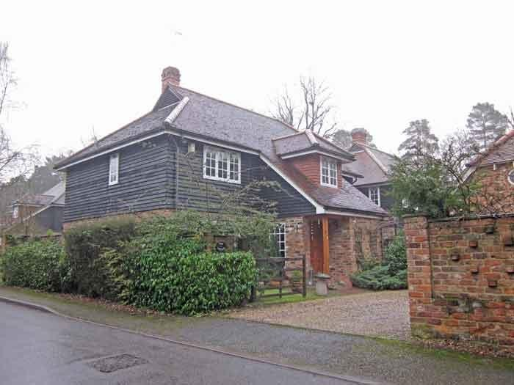

The Wine Vaults – Market Place
Up to 1901
As its name implies, the Wine Vault started life as a wine and spirits merchants. It remained as such for some long time, until being taken over briefly by the Wellington Brewery and then being sold on to Daniel Heron, who switched it to a public house.
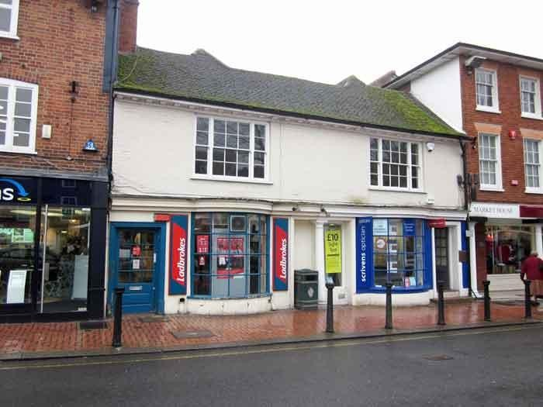
1901 to 2010
Ye Old Leathern Bottel – 221 Barkham Road
Up to 1901
The recorded history of this alehouse begins in 1737 when it was an isolated roadside alehouse in the middle of an area of desolate heath. It was then merely known as the Leathern Bottle. (See also the New Leathern Bottle). Since then there have been many changes of the name; the Bottle, the Old Bottle and the Old Leathern Bottle.

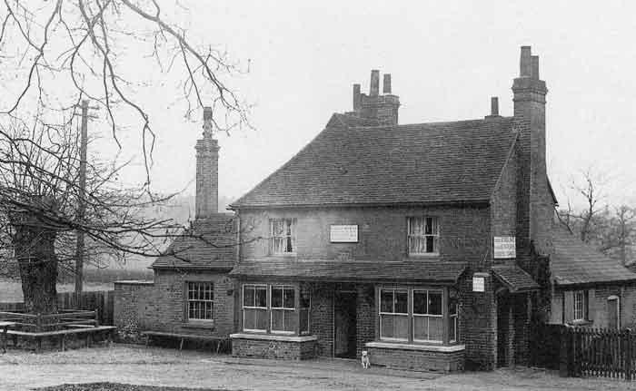
Britain in Old Photographs - Wokingham / Bob Wyatt
1901 to 2011
Yet another variant of the name is now preferred – it's currently a 'Bottel'.
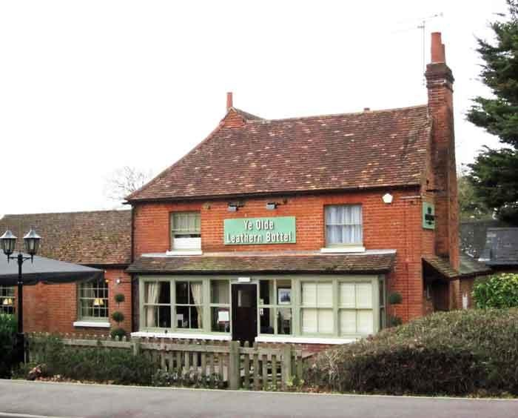

Breweries
Haywards Brewery – Reading Road
Up to 1901
Up until 1856 there was only one significant brewery in Wokingham, that of William Hayward (who had bought the original business from James Webb).
James Webb bought Beches Manor on Reading Road in 1760 and started the brewery on that site. In 1762 he bought the Leathern Bottle for £300 and began the tradition of 'tied houses'.
The brewery by 1856 owned 40% of all the alehouses and public houses.
When it was put up for auction, no other breweries in Wokingham were sufficiently large to put in offers for many of its licensed premises, most going to breweries outside Wokingham – such as Brakspears (Henley) and Hewetts (White Waltham).
1901 to 2011
The site is now occupied by the Wokingham Youth Centre – itself undergoing some renovations.
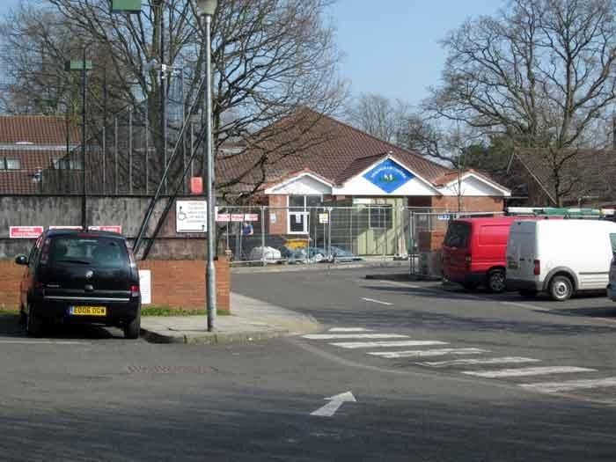
Bakers/The Wokingham Brewery - Broad Street
Up to 1901
Residential sites and industry are seen here side by side, at 15 Broad Street. The Wokingham Brewery is behind No. 15, one of the properties that front onto Broad Street.

Originally Baker's Brewery, it became known as The Wokingham Brewery late in the 19th century. By this time it had acquired at least four public houses, the Crooked Billet, the Crown, The Hope and Anchor and the Railway Hotel.
In 1857 it opened The Shades, a public house, at the front. In 1901 Rosalind Baker was the owner.
It was sold to Brakspears in 1914, but they only wanted its tied properties and the brewery itself closed down early in the 1914-18 war.
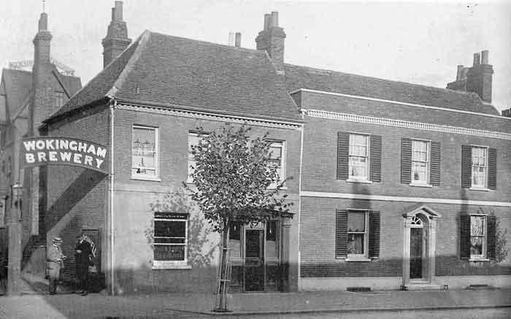
From: Wokingham – A Pictorial History / J&R Lea
1901 to 2011
Although the building on the corner (what was The Shades alehouse) is still recognisable, down the passage way there are now new office developments where the brewery itself was located.

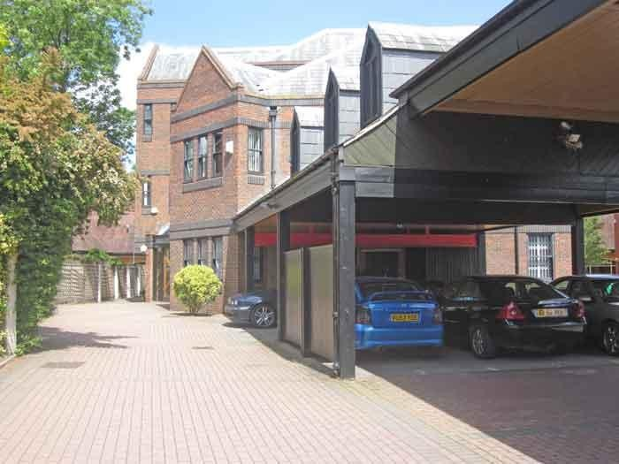
The Wellington/Headington Brewery – Denmark Street
Up to 1901
In 1856, when the Haywards empire was being split up, Robert Trickey Dunnings bought The Chair in Denmark Street. He also bought land behind the Chair, upon which be built the Wellington Brewery. The estate was taken over first by Frank Headington and his cousin Richard Webster, in partnership, and then by Frank's son John, who was the owner in 1901.

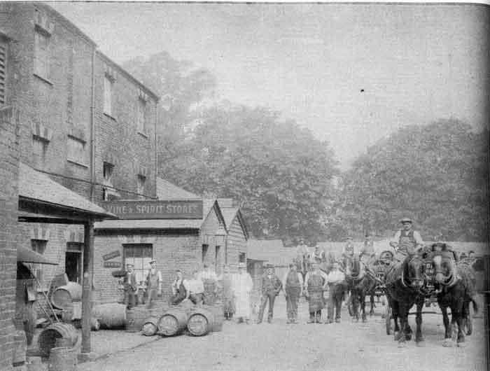
Britain in Old Photographs - Wokingham / Bob Wyatt
1901 to 2011
The brewery flourished until 1920, when it was sold to Ashbys of Staines. As usual in these cases, the new owners wanted the tied pubs as outlets for their own beer, rather than the brewery for its beer.
The site of the brewery is behind 'The Plaza'.

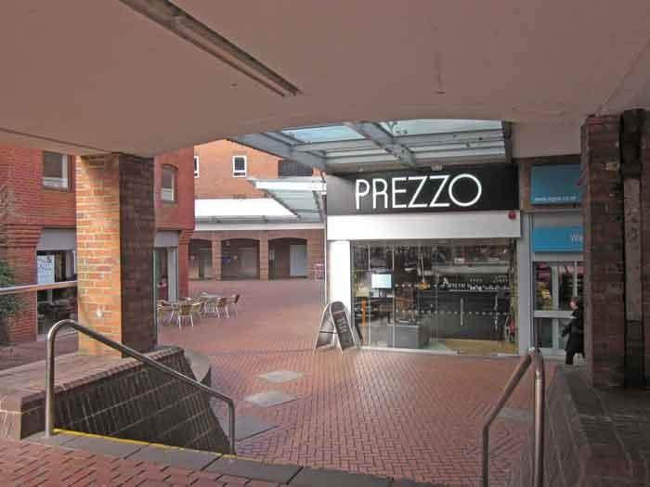
Eagle Brewery – 7 Peach Street
Up to 1901
The small Eagle Brewery at 7 Peach Street opened about 1820. The 1830 Beer Act allowed it to retail its own beer, so it obtained an off-license. In 1854 the brewery was bought by Hewett's Brewery of Waltham St. Lawrence but appears to have closed by 1863, although it continued as a beer and spirits retailer until 1982.

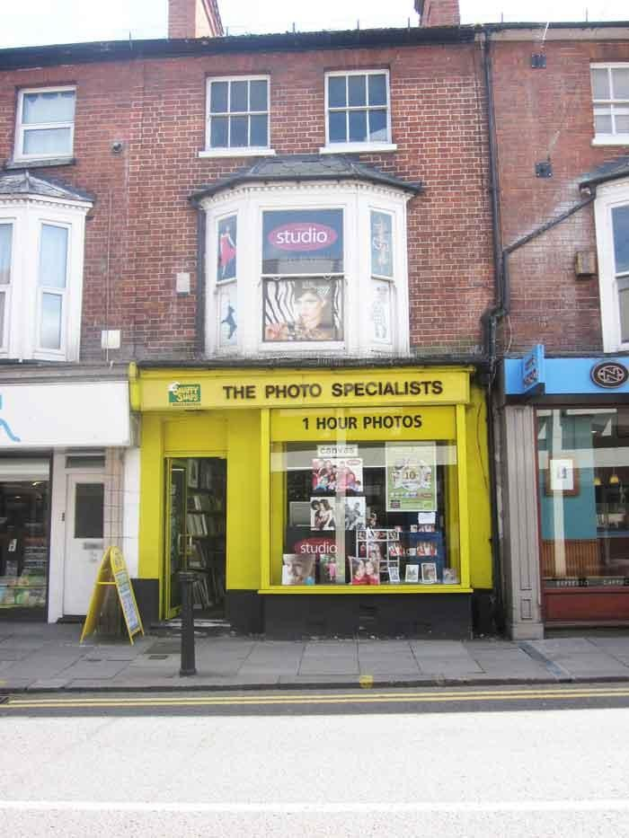
1901 to 2011

Bibliography
Here is a list of the source material used while compiling these pages.

© Chris French 2020

